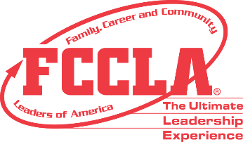

Member Affiliation Information Form

Use this form to collect the required (*) information from prospective FCCLA members before adding them to your FCCLA Chapter roster.

*First Name: ___________________________________________

*Last Name: ___________________________________________

*Grade (circle one): 5, 6, 7, 8, 9, 10, 11, 12

*Gender (circle one): Male, Female, Non-binary

*Demographic (circle one): African American, Asian, Caucasian, Hispanic, Native American, Other, Pacific Islander

*Member Title (circle one): Chapter Member, Chapter Officer, National Officer, Regional Officer, State Officer

*Member Email: _________________________________________
(where unique Student Portal credentials and Member Minute newsletters will be emailed)

Completing this form does not imply that you are affiliated with FCCLA. Members must be entered into the National FCCLA Portal and paid in full each school year before they are considered members of FCCLA.

