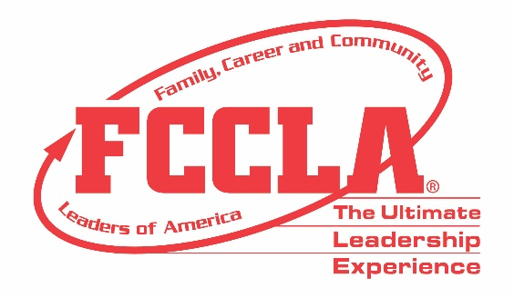

FOR IMMEDIATE RELEASE Contact: Your Name and Title
Phone: Your Phone
Email: Your Email

Students Prepare to be College- and Career-Ready at FCCLA National Fall Conference
(Insert Photo of Students at NFC)

Dallas, TX, November (Insert Date), 2019 – More than 2,500 attendees from across the country traveled to Dallas, Texas, November 15-17 for Family, Career and Community Leaders of America (FCCLA) 2019 National Fall Conference (NFC). This three-day conference offered FCCLA members opportunities to strengthen leadership skills, explore Career Pathways, and compete in career-applicable skill demonstration competitions as well as team events that challenge students’ knowledge in personal finance, consumer responsibility, technology, health and safety, and more!

By attending NFC, FCCLA members ventured to a new city and experienced a new culture which empowered students to return to their families, careers, and communities, with new skills and experiences that will help students excel within college and careers. A highlight of the 2019 NFC was the Socks for the Sole community service project. FCCLA members and advisers in attendance were encouraged to donate new socks which were collected and donated to The Stewpot to benefit the Dallas, TX community’s homeless population.

“FCCLA successfully prepares today’s students for tomorrow’s careers,” said Sandy Spavone, Executive Director of FCCLA. “Through competing in Competitive Events, participating in leadership training to teach employability skills, and attending leadership conferences, FCCLA members develop the skills needed to thrive in the 21st Century.”

FCCLA’s 2019-2020 annual theme, “Your Story,” challenged members to share their personal leadership story throughout NFC and learn from one another. FCCLA will be hosting its annual national conference in Washington, D.C., July 5-9, 2020, where more than 9,000 members, advisers, and supporters are expected to be in attendance as FCCLA celebrates its 75th anniversary.

About FCCLA
Family, Career and Community Leaders of America (FCCLA) is a dynamic and effective national student organization that helps young men and women become leaders and address important personal, family, work, and societal issues through Family and Consumer Sciences education. FCCLA has over 175,000 members and more than 5,300 chapters from 50 state associations, Puerto Rico, and the Virgin Islands.
FCCLA: The Ultimate Leadership Experience is unique among youth organizations because its programs are planned and run by members, and it’s the only career and technical in-school student organization with a central focus on careers that support families. Participation in national FCCLA programs and chapter activities helps members become strong leaders in their families, careers, and communities.
###

