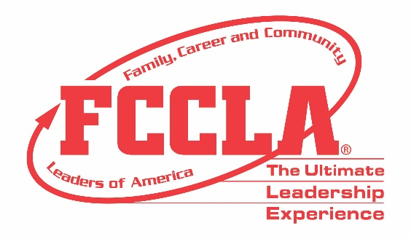

FOR IMMEDIATE RELEASE Contact: Your Name and Title
Phone: Your Phone
Email: Your Email

(Insert Chapter/School Name) Students Make Career Preparation Part of Their Story in Dallas, TX

Dallas, TX, November (Insert Date), 2019 – (Insert Student(s) Name(s)) from (Insert Chapter/School Name) attended the Family, Career and Community Leaders of America (FCCLA) 2019 National Fall Conference (NFC) in Dallas, Texas, November 15-17. FCCLA’s 2019 NFC drew more than 2,500 members, advisers, and supporters from across the nation with opportunities for personal development, career exploration, and community service.

Throughout NFC, attendees heard from keynote speakers, participated in leadership workshops, and competed in career-focused Skill Demonstration Event competitions and team events that tested their knowledge in personal finance, consumer responsibilities, technology, health and safety, and more. FCCLA members also received the opportunity to network with fellow youth leaders and learn more about future career and college options through exploring the career pathways of Human Services, Hospitality and Tourism, Education and Training, and Visual Arts and Design.

In addition, FCCLA attendees took time to give back to the Dallas, TX community by contributing to the Socks for the Sole community service project. FCCLA members and advisers were encouraged to donate socks to The Stewpot to benefit the Dallas community’s homeless population.

Those in attendance at NFC were encouraged by FCCLA’s annual theme, “Your Story,” in which they shared with fellow NFC participants how they utilize the skills, experiences, and knowledge gained through FCCLA to make a difference in their families, careers, and communities across America. (Insert Attendee Name and FCCLA Position) said, “(Insert Quote reflecting on National Fall Conference experience).”
About FCCLA
Family, Career and Community Leaders of America (FCCLA) is a dynamic and effective national student organization that helps young men and women become leaders and address important personal, family, work, and societal issues through Family and Consumer Sciences education. FCCLA has over 175,000 members and more than 5,300 chapters from 50 state associations, Puerto Rico, and the Virgin Islands.
FCCLA: The Ultimate Leadership Experience is unique among youth organizations because its programs are planned and run by members, and it’s the only career and technical in-school student organization with a central focus on careers that support families. Participation in national FCCLA programs and chapter activities helps members become strong leaders in their families, careers, and communities.
###

