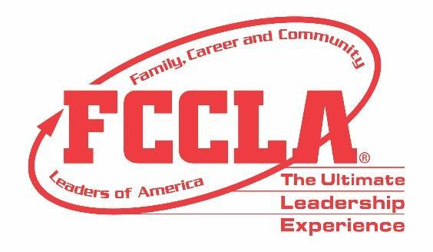

**FOR IMMEDIATE RELEASE** **Contact:** *Marissa Kunerth*

**July 1, 2020** *Communications & Public Relations Manager*

**Phone:** *703.716.1308*

**Email:** [*mkunerth@fcclainc.org*](mailto:mkunerth@fcclainc.org)

**(Chapter Name) FCCLA Chapter Wins National Career Connection Project Award**

**RESTON, VA** — (Chapter), (State), was selected to receive the 2020 National (1st Place High School **OR** 1st Place Middle School **OR** Runner Up) Career Connection Award, sponsored by Goodheart-Willcox Publisher and Family, Career and Community Leaders of America (FCCLA).

Career Connection is a peer education program, created by FCCLA, designed to teach students how to prepare for career success now and in the future. The award recognizes chapters that conduct career development projects to help young people build skills for success in careers, families, and their communities.

(Insert Project Description)

As the national (1st Place High School **OR** 1st Place Middle School **OR** Runner Up), the (Chapter) FCCLA chapter will receive a (Award Amount) award and will be recognized at FCCLA’s 2020 Virtual National Leadership Conference, July 7-9, 2020.

***About FCCLA***

Family, Career and Community Leaders of America ([FCCLA](http://www.fcclainc.org/)) is a dynamic and effective national student organization that helps young men and women become leaders and address important personal, family, work, and societal issues through Family and Consumer Sciences education. FCCLA has more than 182,000 members and 5,253 chapters from 48 state associations, Puerto Rico, and the Virgin Islands.

**About Goodheart-Willcox Publisher**

*Experts in Career and Technical Education, Goodheart-Willcox was established in 1921 and has continually published the highest quality content for CTE. Subject areas include Family and Consumer Sciences; Business, Marketing, and Career Education; Health and Health Sciences; Automotive; Technical, Trades, and Engineering; and Agricultural Education. Goodheart-Willcox titles are available in print and digital formats, and include a full portfolio of student and instructor resources. For more information, please visit* [www.g-w.com](http://r20.rs6.net/tn.jsp?f=001gRS7js5xKDauv49YZbkCM4qV2PssqtPpu8fxYRQjzFvcLtFKzeCIBJLmt_izvdf0yFOdax1dYzgXNt_fiL88qmXLID7sdV5xRoa86d9DKiYeyDfJO4KyKVbr6fzEf-phs4x8CnSJZkxAVnKDTjfwebO6JHOHVJer&c=PK8Hfc7PLj-7XTasI7CRB8TLoxD4g2HkKDAYdzeZf83bN2UCFPKd8w==&ch=iZ_MurGyRx9vgfvWRU9DSE3T4SMMyZN13HeoF06Ac2rTJvmEacKZ5Q==)*. Goodheart-Willcox: We Build Careers*

###