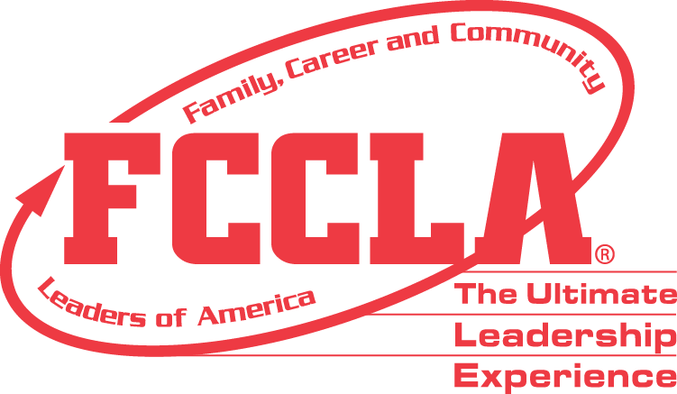

**FOR IMMEDIATE RELEASE** **Contact:** *Marissa Kunerth*

**July 1, 2020** *Communications & Public Relations Manager*

**Phone:** *703.716.1308*

**Email:** [*mkunerth@fcclainc.org*](mailto:mkunerth@fcclainc.org)

**(Chapter Name) FCCLA Chapter Wins National Community Service Project Award**

**RESTON, VA** — (Chapter Name), (State), was selected to receive the 2020 National (1st Place High School **OR** 1st Place Middle School **OR** Runner Up) Community Service Award, a program of Family, Career and Community Leaders of America (FCCLA). These awards are sponsored by [Access from AT&T](https://www.att.com/shop/internet/access/#!/).

Community Service is an FCCLA program that guides students to develop, plan, carry out, and evaluate projects that improve the quality of life in their communities. The award recognizes chapters that identify a community need and promote community involvement to meet that need. This dynamic and interactive program guides students through three essential topics: **Learn** - Students explore personal values, ethics, and ethical decision-making while evaluating their community needs; **Lead –**Students learn how to use their leadership skills to serve their community and how to transfer those servant leadership skills to the workplace; **Serve –**Students are introduced to the critical role community partnerships and advocacy play in serving the needs of others while also developing their own community-based service.

(Insert Project Description)

As the national (1st Place High School **OR** 1st Place Middle School **OR** Runner Up), the (Chapter Name) FCCLA chapter will receive a (Award Amount) award and will be recognized at the 2020 FCCLA Virtual National Leadership Conference, July 7-9, 2020.

***About FCCLA***

Family, Career and Community Leaders of America ([FCCLA](http://www.fcclainc.org/)) is a dynamic and effective national student organization that helps young men and women become leaders and address important personal, family, work, and societal issues through Family and Consumer Sciences education. FCCLA has more than 182,000 members and 5,253 chapters from 48 state associations, Puerto Rico, and the Virgin Islands.

###