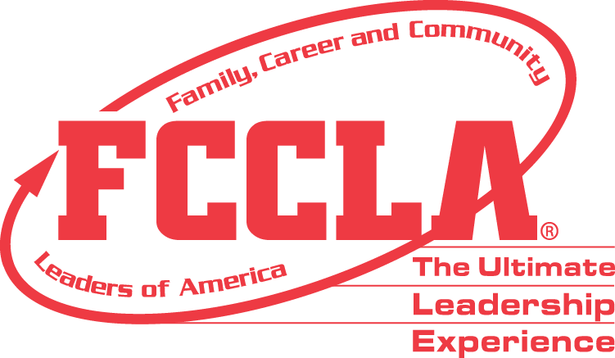

**FOR IMMEDIATE RELEASE** **Contact:** *Marissa Kunerth*

**July 1, 2020** *Communications & Public Relations Manager*

**Phone:** *703.716.1308*

**Email:** [*mkunerth@fcclainc.org*](mailto:mkunerth@fcclainc.org)

**(Chapter Name) FCCLA Chapter Wins National FACTS Project Award**

**RESTON, VA**— (Chapter Name), (State), was selected to receive the 2020 national (1st Place High School **OR** 1st Place Middle School **OR** Runner Up) Families Acting for Community Traffic Safety (FACTS) Award. This award is sponsored by Ford Fund’s signature teen safe driving program, Ford Driving Skills for Life (DSFL), as a program of Family, Career and Community Leaders of America (FCCLA), in partnership with the Governors Highway Safety Association (GHSA).

FACTS is a national peer-to-peer education program through which students strive to save lives through personal, vehicle, and road safety. The purpose of the FACTS award program is to encourage local chapter members to identify a specific community traffic safety problem and carry out an innovative project to address that need. Using their Family and Consumer Sciences skills, members can take the lead in their communities and show how youth can make a difference.

(Insert Project Description)

As the national (1st Place High School **OR** 1st Place Middle School **OR** Runner Up), the (Chapter Name) FCCLA chapter will receive a (Award Amount) award and will be recognized at the 2020 FCCLA Virtual National Leadership Conference, July 7-9, 2020.

***About FCCLA***

Family, Career and Community Leaders of America ([FCCLA](http://www.fcclainc.org/)) is a dynamic and effective national student organization that helps young men and women become leaders and address important personal, family, work, and societal issues through Family and Consumer Sciences education. FCCLA has more than 182,000 members and 5,253 chapters from 48 state associations, Puerto Rico, and the Virgin Islands.

***About Ford Driving Skills for Life***

*Ford Driving Skills for Life was established in 2003 by Ford Motor Company Fund, the Governors Highway Safety Association, and a panel of safety experts to teach newly licensed teens and parents the necessary skills for safe driving. Now in its fifteenth year, the premise behind Ford Driving Skills for Life is to provide a step in the learning process by providing new skills and information not currently shared with newly licensed drivers in the basic driver education courses. The program has trained more than 1 million individuals in safe driving practices. It is offered in over 40 countries, and hands-on driving clinics have been conducted in all 50 U.S. states, Puerto Rico and the District of Columbia. For more information visit* [*www.drivingskillsforlife.com*](https://urldefense.proofpoint.com/v2/url?u=http-3A__www.drivingskillsforlife.com&d=DwMFAg&c=qwStF0e4-YFyvjCeML3ehA&r=ITN-_HQmt8ecQXRqd-N6IZ0REaA1mErJuyJwCyD4hK8&m=Ifgt7EBSsI1SCKIJ0M4bKf8WjowoqohoK2bbPfQ2N8Y&s=cIeiW8KCpvnzAsPRPVtrqM56SceyKvTTUzIQzH-7Ess&e=)*.*

***About Governors Highway Safety Association***

*The Governors Highway Safety Association (GHSA) is a nonprofit association representing the highway safety offices of states, territories, the District of Columbia and Puerto Rico. GHSA provides leadership and representation for the states and territories to improve traffic safety, influence national policy, enhance program management and promote best practices. Its members are appointed by their Governors to administer federal and state highway safety funds and implement state highway safety plans. Contact GHSA at 202-789-0942 or visit*[*www.ghsa.org*](http://www.ghsa.org/)*. Find us on Facebook at*[*www.facebook.com/GHSAhq*](http://www.facebook.com/GHSAhq)*or follow us on Twitter @GHSAHQ.*

###