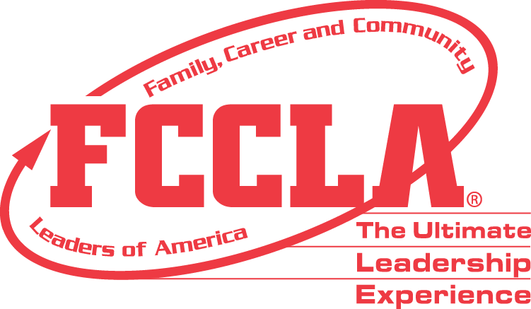

**FOR IMMEDIATE RELEASE** **Contact:** *Marissa Kunerth*

**July 1, 2020** *Communications & Public Relations Manager*

**Phone:** *703.716.1308*

**Email:** [*mkunerth@fcclainc.org*](mailto:mkunerth@fcclainc.org)

**(Chapter Name) FCCLA Chapter Wins National Families First Project Award**

**RESTON, VA** — (Chapter Name), (State), was selected to receive the 2020 national (1st Place High School **OR** 1st Place Middle School **OR** Runner Up) Families First Award, sponsored by Family, Career and Community Leaders of America (FCCLA).

Families First is a peer education program, created by FCCLA, through which youth gain a better understanding of how families work and learn skills to become strong family members. Its goals are to: help youth become strong family members and leaders for today and tomorrow and strengthen the family as the basic unit of society.

(Insert Project Description)

As the national (1st Place High School **OR** 1st Place Middle School **OR** Runner Up), the (Chapter Name) FCCLA chapter will receive a (Award Amount) award and will be recognized at the 2020 FCCLA Virtual National Leadership Conference, July 7-9, 2020.

***About FCCLA***

Family, Career and Community Leaders of America ([FCCLA](http://www.fcclainc.org/)) is a dynamic and effective national student organization that helps young men and women become leaders and address important personal, family, work, and societal issues through Family and Consumer Sciences education. FCCLA has more than 182,000 members and 5,253 chapters from 48 state associations, Puerto Rico, and the Virgin Islands.

###