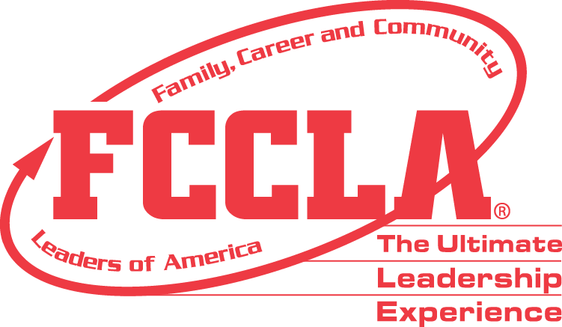

**FOR IMMEDIATE RELEASE** **Contact:** *Marissa Kunerth*

**July 1, 2020** *Communications & Public Relations Manager*

**Phone:** *703.716.1308*

**Email:** [*mkunerth@fcclainc.org*](mailto:mkunerth@fcclainc.org)

**(Chapter Name) FCCLA Chapter Wins National Financial Fitness Project Award**

RESTON, VA — (Chapter Name), (State), was selected to receive the 2020 national (1st Place High School **OR** 1st Place Middle School **OR** Runner Up) Financial Fitness Award, sponsored by Family, Career and Community Leaders of America (FCCLA).

Financial Fitness is a peer education program, created by FCCLA, designed to help youth develop skills in money management, consumerism, and financial planning. The award recognizes chapters that promote making, saving, and spending money wisely.

(Insert Project Description)

As the national (1st Place High School **OR** 1st Place Middle School **OR** Runner Up), the (Chapter Name) FCCLA chapter will receive a (Award Amount) award and will be recognized at the 2020 FCCLA Virtual National Leadership Conference, July 7-9, 2020.

***About FCCLA***

Family, Career and Community Leaders of America ([FCCLA](http://www.fcclainc.org/)) is a dynamic and effective national student organization that helps young men and women become leaders and address important personal, family, work, and societal issues through Family and Consumer Sciences education. FCCLA has more than 182,000 members and 5,253 chapters from 48 state associations, Puerto Rico, and the Virgin Islands.

###