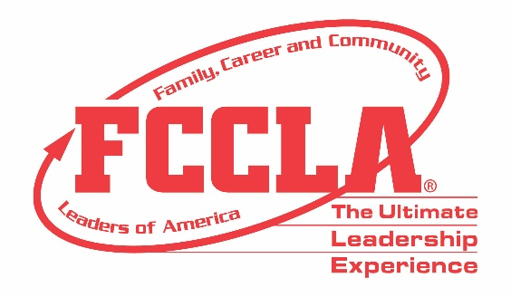

**FOR IMMEDIATE RELEASE** **Contact:** *Marissa Kunerth*

**July 1, 2020** *Communications & Public Relations Manager*

**Phone:** *703.716.1308*

**Email:** *mkunerth@fcclainc.org*

**Largest Gathering of Family and Consumer Sciences Educators and Students Doesn’t Let COVID-19 Cancel Organization’s Option to “Meet”**

**RESTON, VA –** Family, Career and Community Leaders of America (FCCLA) will hold its first-ever virtual conference since the organization was founded in 1945. Instead of gathering in-person and rocking red blazers in the nation’s capital as planned, students will log on to an online platform that blends virtual reality and gamification technology to transform FCCLA’s National Leadership Conference into a dynamic, “on-demand” virtual experience. In transitioning to an online conference, keynote speakers, breakout sessions, EXPO, Competitive Events, networking opportunities, and more will shift to a virtual platform to continue to provide students with the Ultimate Leadership Experience they anxiously anticipate and prepare for all year.

“FCCLA’s 2020 Virtual National Leadership Conference will be an unforgettable experience filled with leadership trainings, virtual professional skill demonstrations led by national experts, adviser professional development opportunities, a few extra special surprises, and a celebration of the FCCLA class of 2020,” said Sandy Spavone, Executive Director of FCCLA.

Throughout this school year, members were encouraged to use this year’s theme, “Your Story,” which focused on how over the past 75 years each member’s story over has helped write the organization’s collective story. As the year has progressed and the impact of COVID-19 has ripped the drafted planned pages of the stories originally envisioned, FCCLA is excited to be able to offer members an opportunity to continue their engagement in FCCLA through the virtual world that we all are living in at the moment.

“I cannot wait to “see” my FCCLA family this summer as we write our National Leadership Conference story, virtual edition,” said Tyler Lemley, National President of FCCLA. “As a graduating senior of the Class of 2020, I am disappointed to miss seeing thousands of us together at our conference but excited to be part of the leadership team planning this first-ever virtual conference for our members.”

FCCLA looks forward to offering all members the opportunity to take part in the Virtual National Leadership Conference. This year’s Virtual National Leadership Conference is sure to be a memorable chapter in FCCLA’s story as the organization celebrates its 75th anniversary and honors FCCLA’s Class of 2020. All students who are interested in joining FCCLA are encouraged to contact their chapter’s FCCLA adviser or Family and Consumer Sciences teacher to see how they can make FCCLA a part of their story today!

***About FCCLA***

Family, Career and Community Leaders of America ([FCCLA](http://www.fcclainc.org/)) is a dynamic and effective national student organization that helps young men and women become leaders and address important personal, family, work, and societal issues through Family and Consumer Sciences education. FCCLA has more than 182,000 members and 5,253 chapters from 48 state associations, Puerto Rico, and the Virgin Islands.

###