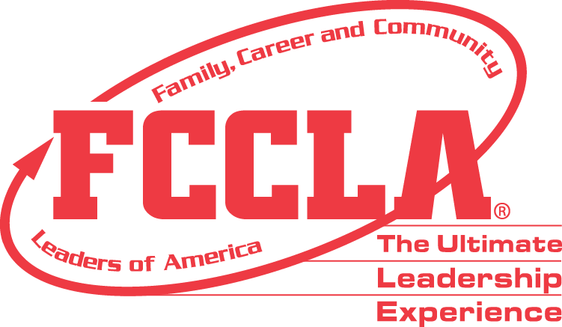

**FOR IMMEDIATE RELEASE** **Contact:** *Marissa Kunerth*

**July 1, 2020** *Communications & Public Relations Manager*

**Phone:** *703.716.1308*

**Email:** [*mkunerth@fcclainc.org*](mailto:mkunerth@fcclainc.org)

**(Chapter Name) FCCLA Chapter Wins National Stop The Violence Project Award**

RESTON, VA — (Chapter Name), (State), was selected to receive the 2020 national (1st Place High School **OR** 1st Place Middle School **OR** Runner Up) Students Taking on Prevention (STOP) the Violence Award, sponsored by CareerSafe and a program of Family, Career and Community Leaders of America (FCCLA).

The FCCLA program, STOP the Violence is a peer-to-peer outreach initiative that empowers young people to recognize, report, and reduce the potential for youth violence and bullying.STOP the Violence awards recognize outstanding chapters that develop, carry out, and analyze exceptional projects.

(Insert Project Description)

As the national (1st Place High School **OR** 1st Place Middle School **OR** Runner Up), the (Chapter Name) FCCLA chapter will receive a (Award Amount) award and will be recognized at the 2020 FCCLA Virtual National Leadership Conference, July 7-9, 2020.

***About FCCLA***

Family, Career and Community Leaders of America ([FCCLA](http://www.fcclainc.org/)) is a dynamic and effective national student organization that helps young men and women become leaders and address important personal, family, work, and societal issues through Family and Consumer Sciences education. FCCLA has more than 182,000 members and 5,253 chapters from 48 state associations, Puerto Rico, and the Virgin Islands.

***About CareerSafe***

*CareerSafe’s mission is to deliver Safety Education for America's Future. Our vision is to advance and enhance OSHA’s outreach by providing every young worker with workplace safety training prior to taking their first job. Whether a student faces hazards on the job or dangers online, CareerSafe has multiple courses to teach students best practices to abate and mitigate those risks. CareerSafe has reached over 1.2 million young workers and plan to reach many more. To this end, we are committed to offering affordable, informative and innovative online safety training to reach as many young workers as possible.*

*###*