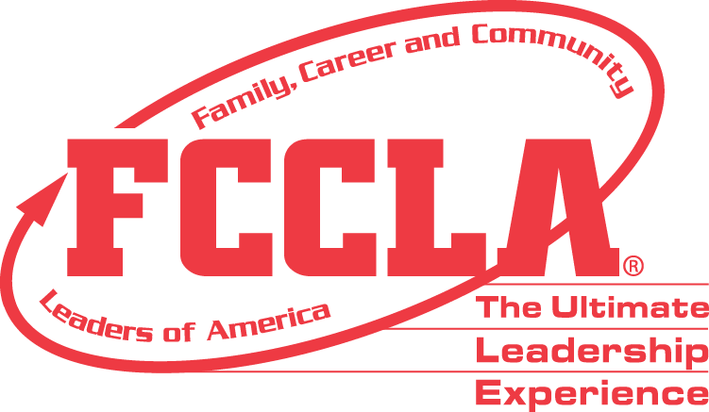

**FOR IMMEDIATE RELEASE** **Contact:** *Marissa Kunerth*

**July 1, 2020** *Communications & Public Relations Manager*

**Phone:** *703.716.1308*

**Email:** [*mkunerth@fcclainc.org*](mailto:mkunerth@fcclainc.org)

**(Chapter Name) FCCLA Chapter Wins National Student Body Project Award**

RESTON, VA — (Chapter Name), (STATE), was selected to receive the 2020 National (1st Place High School **OR** 1st Place Middle School **OR** Runner Up) Student Body Award, sponsored by the Campaign for Tobacco-Free Kids (CTFK) as a program of Family, Career and Community Leaders of America (FCCLA).

Student Body, a national peer-to-peer education program created by FCCLA, is designed to teach students how to make informed, responsible decisions about their health and provide opportunities for youth to teach others about making healthy choices. The Student Body award recognizes chapters that promote the healthy you, the fit you, the real you, and the resilient you.

(Insert Project Description)

As the national (1st Place High School **OR** 1st Place Middle School **OR** Runner Up), the (Chapter Name) FCCLA chapter will receive a (Award Amount) award and will be recognized at FCCLA’s Virtual National Leadership Conference, July 7 – 9, 2020.

***About FCCLA***

Family, Career and Community Leaders of America ([FCCLA](http://www.fcclainc.org/)) is a dynamic and effective national student organization that helps young men and women become leaders and address important personal, family, work, and societal issues through Family and Consumer Sciences education. FCCLA has more than 182,000 members and 5,253 chapters from 48 state associations, Puerto Rico, and the Virgin Islands.

***About the Campaign for Tobacco-Free Kids***

*The Campaign for Tobacco-Free Kids is the leading advocacy organization working to reduce tobacco use and its deadly consequences in the United States and around the world. Through strategic communications and policy advocacy campaigns, the Campaign for Tobacco-Free Kids promotes the adoption of proven solutions that are most effective at reducing tobacco use and saving the most lives.*

*###*