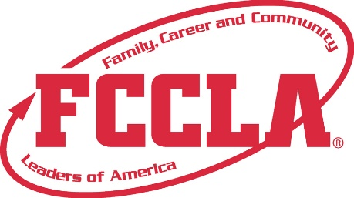

FOR IMMEDIATE RELEASE Contact: Your Name and Title
Phone: Your Phone
Email: Your Email

(Name of High School or Student(s)) Advocate on Capitol Hill for
Support of Career and Technical Education
(Add photo)

November, 2021, Washington, D.C.— The U.S. Capitol was filled with youth from around the country as Family, Career and Community Leaders of America (FCCLA) and Family and Consumer Sciences (FCS) professionals united in Washington, D.C. for FCCLA’s Capitol Leadership to advocate for additional funding for Career and Technical Education (CTE) November 5-6, 2021.
(Insert Attendees Name(s)) from (Insert City/Chapter Name) attended FCCLA’s Capitol Leadership where they/he/she used their/his/her voice and passion to join together with youth leaders from across the nation in meeting with congressional leaders and promoting the need continue to Fund Career and Technical Education. (Name of Chapter/Student) had the opportunity to personally meet with (Name of Senator/Representative) to seek support for making Family and Consumer Sciences education available for every student in every state.
“[Insert quote from student about Capitol Leadership experience],” said (Student’s Name), (Officer Position, if any) from (School’s Name).
Capitol Leadership was the first national FCCLA gathering held this school year. FCCLA members and other FCS leaders will continue to strengthen leadership skills, learn important real-world skills, and explore Career Pathways through FCCLA’s upcoming conferences and events including: National Fall Conference in Washington, DC, and the 2022 National Leadership Conference in San Diego, CA.
About FCCLA
Family, Career and Community Leaders of America (FCCLA) is a dynamic and effective national student organization that helps young men and women become leaders and address important personal, family, work, and societal issues through Family and Consumer Sciences education. FCCLA has over 155,000 members and more than 5,300 chapters from 50 state associations, Puerto Rico, and the Virgin Islands.
FCCLA: The Ultimate Leadership Experience is unique among youth organizations because its programs are planned and run by members, and it’s the only career and technical in-school student organization with a central focus on careers that support families. Participation in national FCCLA programs and chapter activities helps members become strong leaders in their families, careers, and communities.
For more information on FCCLA, please contact (Insert Adviser Name) at (School Phone Number) or (Email Address).
###

