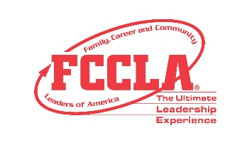
JUSTIFICATION TO ATTEND LETTER

<Date>

Dear <supervisor's name>,
Our <Insert chapter name> Chapter of FCCLA would like to request your support in obtaining financial assistance to attend FCCLA Capital Leadership in Washington D.C., November 4-5, 2021. During Capitol Leadership, students will receive training focusing on networking, professionalism, strategic planning, and advocacy around key teen-centered current issues. Students will advocate for Family and Consumer Sciences and Career and Technical Education by showing policymakers how their support for education impacts teens in preparing to be college and career ready. An important aspect of Capitol Leadership features today’s teens meeting with their representatives to explain the importance of continued support for the Strengthening Career and Technical Education Act. Capitol Leadership is the first of several large gatherings FCCLA will host throughout the 2021-2022 school year to provide similar opportunities to students around the nation.

The following is an estimate of our costs:
Registration: <$xxxx>
Roundtrip Airfare: <$xxxx>
Motor Coach Transportation: <$xxxx>
Ground Transportation: <$xxxx>
Hotel: <$xxxx >
Meals: <$xxxx>

Workshop topics, session format, and the tentative meeting agenda are provided on the attached documentation. I believe this is a great investment in our students and myself and hope you agree by supporting our request for financial support. Thank you for your consideration in supporting our FCCLA chapter’s attendance at Capitol Leadership. Please let me know if you need additional information to provide financial assistance for this event.

Attachment: FCCLA Capitol Leadership Agenda
Sincerely,
<Insert your name here>

