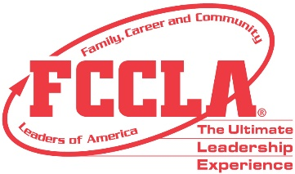
PROCLAMATION
FCCLA WEEK
FEBRUARY 8-12, 2021

WHEREAS,
Family, Career and Community Leaders of America (FCCLA), the national nonprofit, family-focused, intracurricular student organization for Family and Consumer Sciences students through grade 12, helps youth assume their roles in society through Family and Consumer Sciences education in the areas of personal growth, family life, college readiness, career exploration, leadership, and community involvement; and
WHEREAS,
The organization extends classroom learning through chapter service projects that develop leadership and employability skills, and helps young men and women learn how to plan, make decisions, and carry out and evaluation programs of action through working with other youth and adults within their school, community, and state; and
WHEREAS,
FCCLA offers members an opportunity to work together for common purposes for the improvement of themselves, as well as their families, careers, and communities; and
WHEREAS,
The week of February 8 through 12, 2021 has been designated national FCCLA Week with the theme, “Beyond Measure.”
NOW, THEREFORE,
I, ______________________ (elected official), hereby proclaim the week beginning February 8, 2021 as national FCCLA Week in ___________________ (your community/state) and urge all citizens to acquaint themselves with the activities and values of Family, Career and Community Leaders of America, to show interest in, and provide support and encouragement to the students who are working to achieve knowledge and experience that will help prepare them for future responsibilities as active and concerned adult members of society.

__________________________________ _______________________ _________________
Signature Title Date

