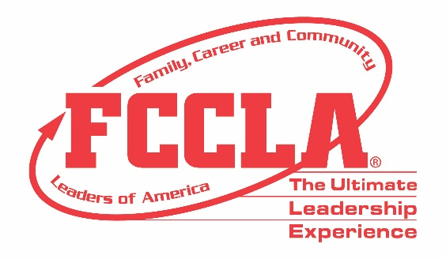

FOR IMMEDIATE RELEASE Contact: Your Name and Title
Phone: Your Phone
Email: Your Email

(Insert Chapter/School Name) Students Make Career Preparation Count in Washington, DC

Washington, DC, November (Insert Date), 2021 – (Insert Student(s) Name(s)) from (Insert Chapter/School Name) attended the Family, Career and Community Leaders of America (FCCLA) 2021 National Fall Conference (NFC) in Washington, DC, November 5-7. FCCLA’s 2021 NFC drew more than 700 members, advisers, and supporters from across the nation with opportunities for personal development, career exploration, and community service.

Throughout NFC, attendees heard from keynote speakers, participated in leadership workshops, and made their voices heard. Before the conference took place, students virtually competed in career-focused Skill Demonstration Event competitions and team events that tested their knowledge in personal finance, consumer responsibilities, technology, health and safety, and more. FCCLA members also received the opportunity to network with fellow youth leaders and learn more about future career and college options through exploring the career pathways of Human Services, Hospitality and Tourism, Education and Training, and Visual Arts and Design.

Those in attendance at NFC were encouraged by FCCLA’s annual theme, “Make it Count,” in which they shared with fellow NFC participants how they utilize the skills, experiences, and knowledge gained through FCCLA to make a difference in their families, careers, and communities across America. (Insert Attendee Name and FCCLA Position) said, “(Insert Quote reflecting on National Fall Conference experience).”

About FCCLA
Family, Career and Community Leaders of America (FCCLA) is a dynamic and effective national student organization that helps young men and women become leaders and address important personal, family, work, and societal issues through Family and Consumer Sciences education. FCCLA has over 155,000 members and more than 5,300 chapters from 50 state associations, Puerto Rico, and the Virgin Islands.
FCCLA: The Ultimate Leadership Experience is unique among youth organizations because its programs are planned and run by members, and it’s the only career and technical in-school student organization with a central focus on careers that support families. Participation in national FCCLA programs and chapter activities helps members become strong leaders in their families, careers, and communities.
###

