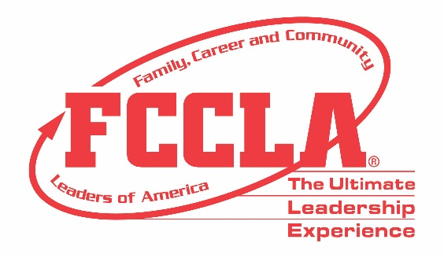

FOR IMMEDIATE RELEASE Contact: Your Name and Title
Phone: Your Phone
Email: Your Email

(Name of School) Students Competed in Skill Demonstration Events at FCCLA National Fall Conference
(send photo of Skill Demonstration Event team)

Washington, DC, November (Insert Date), 2021 – (Insert Student(s) Name(s)) from (Insert Chapter/School Name) traveled to Washington, DC, November 5-7, for the 2021 Family, Career and Community Leaders (FCCLA) National Fall Conference (NFC). More than 700 participants from across the nation gathered to hear from keynote speakers, engage in leadership workshops, participate in a community service project, and explore the four career pathways of Human Services, Hospitality and Tourism, Education and Training, and Visual Arts and Design.

In addition, (Insert Students Names) represented (Insert Chapter/School Name) at NFC by competing in a Skill Demonstration Event. Skill Demonstration Events provide opportunities for members to demonstrate college- and career-ready skills in Family and Consumer Sciences and related occupations. 392 students participated in the 2021 NFC Skill Demonstration Events and (Insert Student(s) Name(s)) placed (Insert Place) in (Insert SDE Name).

“(Insert quote from student about Skill Demonstration Event competition and his/her FCCLA NFC experience overall),” said (Insert Student’s Name and officer position, if any).

Attending NFC and participating in Competitive Events such as Skill Demonstration Events equips students with the tools, knowledge, and opportunities needed to be college- and career-ready. Members utilize the skills learned and experiences gained through FCCLA to improve families, careers, and communities across America.

About FCCLA
Family, Career and Community Leaders of America (FCCLA) is a dynamic and effective national student organization that helps young men and women become leaders and address important personal, family, work, and societal issues through Family and Consumer Sciences education. FCCLA has over 155,000 members and more than 5,300 chapters from 50 state associations, Puerto Rico, and the Virgin Islands.
FCCLA: The Ultimate Leadership Experience is unique among youth organizations because its programs are planned and run by members, and it’s the only career and technical in-school student organization with a central focus on careers that support families. Participation in national FCCLA programs and chapter activities helps members become strong leaders in their families, careers, and communities.
###

