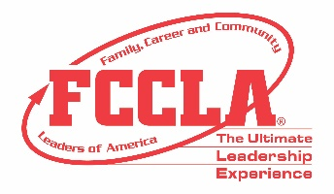
JUSTIFICATION TO ATTEND NLC LETTER

<Date>

Dear <supervisor's name>,
Our <chapter name> Chapter of Family, Career and Community Leaders of America (FCCLA) has worked diligently this year on learning new concepts in Family and Consumer Sciences. I’d like to request your support in obtaining financial assistance to attend the 2021 FCCLA National Leadership Conference (NLC) in Nashville, TN from <attendance dates>. NLC is a student leadership conference designed for middle and high school students and their Family and Consumer Sciences educators. The FCCLA National Leadership Conference is the largest national gathering of Family and Consumer Sciences professionals and students across America.

The conference also offers advisers a comprehensive educational experience to enhance classroom instruction through engaging sessions on a variety of topics with expert speakers, best practices sessions and networking opportunities. Facilitated by National FCCLA, conference sessions will be presented by subject-matter experts, current on educational trends and needs with a variety of backgrounds in communications, marketing, education, and business. The knowledge and skills I will acquire from professional development will be applicable to current projects such as <current projects unique to your institution, mission, and objectives> Continuing Education Unit (CEU) credits will be offered and awarded to participants completing all professional learning activities. The CEU credit can be applied to my professional development requirements.
The following is an estimate of our costs:
Registration: <$xxxx>
Roundtrip Airfare: <$xxxx>
Motor Coach Transportation: <$xxxx>
Ground Transportation: <$xxxx>
Hotel: <$xxxx >
Meals: <$xxxx>

Workshop topics, session format, and the conference schedule are listed in the attached documentation. I believe this is a great investment in our students and hope you agree by supporting our request for financial support. It is an honor to have the opportunity to represent our state and school at this national event. We are committed to using our time in Nashville, TN at NLC to learn, grow, and explore the many career opportunities that will prepare our students to be leaders in their families, careers, and communities. Thank you for your consideration in supporting our FCCLA chapter’s attendance at this important professional and leadership development conference. Please let me know if you need additional information to provide financial assistance for this event.

Sincerely,

<your name here>

Attachment: NLC Guide and Conference Schedule

