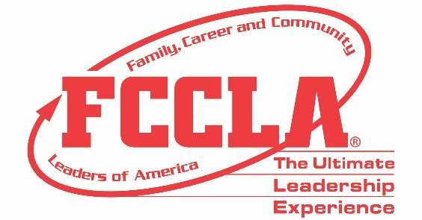

FOR IMMEDIATE RELEASE Contact: Marissa Kunerth
Communications & Public Relations Manager
Phone: 703-716-1308
Email: mkunerth@fcclainc.org

FCCLA Awards Top Three FCCLA/LifeSmarts Knowledge Bowl Winners at 2021 Hybrid National Leadership Conference

Reston, VA – 16 teams from nine states advanced to compete virtually in the 2021 Family, Career and Community Leaders of America (FCCLA)/LifeSmarts Knowledge Bowl national competition this past June. Mason County FCCLA from Kentucky placed third, Clark FCCLA Chapter from South Dakota took second, and Selah High School FCCLA from Washington was named this year’s national champions.
(Insert Quote from Knowledge Bowl Team about Competing)
Through the FCCLA/LifeSmarts Knowledge Bowl team competition, members participate in both online and on-site matches. The three-level team competition challenges students’ knowledge in six content areas: Personal Finance, Consumer Rights and Responsibilities, Technology, Health and Safety, Environment, and FCCLA Knowledge.
FCCLA/LifeSmarts Knowledge Bowl questions come from a variety of sources. In preparation, students are encouraged to utilize Family and Consumer Sciences textbooks, reference guides, content area websites, National FCCLA website, and other local or online resources.
FCCLA/LifeSmarts Knowledge Bowl is held annually at FCCLA’s National Leadership Conference in partnership with National Consumers League. All three FCCLA/LifeSmarts Knowledge Bowl winners will be honored during the Recognition Session at FCCLA’s 2021 National Leadership Conference, June 27-July 2, 2021.

About FCCLA
Family, Career and Community Leaders of America (FCCLA) is a dynamic and effective national student organization that helps young men and women become leaders and address important personal, family, work, and societal issues through Family and Consumer Sciences education. FCCLA reaches more than 180,000 members and over 5,000 Family and Consumer Sciences educators in the United States and territories.

###

