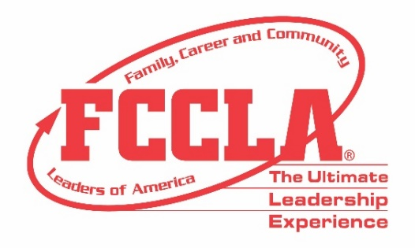

FOR IMMEDIATE RELEASE Contact: Marissa Kunerth
Communications & Public Relations Manager
Phone: 703-716-1308
Email: mkunerth@fcclainc.org

(School/Chapter) FCCLA Members Advance to Compete in STAR Events at the 2021 National Leadership Conference

Reston, VA – Not even a global pandemic can stop Family, Career and Community Leaders of America (FCCLA) members from making a difference in their families, careers, and communities. Although this school year looked a bit different, FCCLA members perseverance, tenacity, and resilience shined through as students nationwide participated in Student Taking Action with Recognition (STAR) Event projects. The top STAR Event competitors from each state, advanced to compete virtually at the 2021 Hybrid National Leadership Conference, June 27-July 2, 2021.
(Insert Member or Adviser Quote)
STAR Events are Competitive Events in which members are recognized for their proficiency and achievement in chapter and individual projects, leadership skills, and career preparation. STAR Events allow student to compete individually or as a team. There are more than 30 STAR Events students can choose to compete in, all which recognize participants who demonstrate their knowledge, skills, and abilities to actively identify an issue concerning families, careers, or communities, research the topic, and develop and implement a project to advocate for positive change.
Both youth and adults work together in managing the events and serving as evaluators of the participants. STAR Events aim to support student development of knowledge and skills by enhancing the classroom experience and Career Pathway initiatives by equipping students with employable skills and industry insights needed to thrive in the 21st century.
In order to advance to compete on the national level in a STAR Event, members first compete at the region/district and state level. (Insert the Name(s) of Chapter Member) competed in (Name of STAR Event Category) and was awarded a (bronze/silver/gold medal/certificate) in his/hers/their STAR Event category and was recognized for his/hers/their accomplishments at FCCLA’s 2021 Hybrid National Leadership Conference.
About FCCLA
Family, Career and Community Leaders of America (FCCLA) is a dynamic and effective national student organization that helps young men and women become leaders and address important personal, family, work, and societal issues through Family and Consumer Sciences education. FCCLA reaches more than 180,000 members and over 5,000 Family and Consumer Sciences educators in the United States and territories.

###

