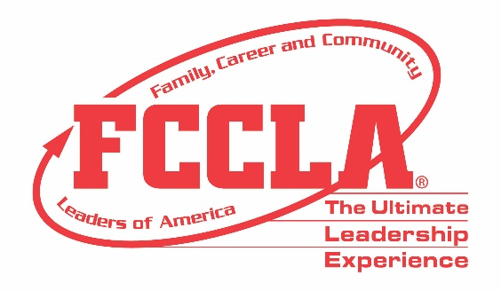

FOR IMMEDIATE RELEASE Contact: Marissa Kunerth
Communications & Public Relations Manager
Phone: 703-716-1308
Email: mkunerth@fcclainc.org

FCCLA is the Only Career and Technical Student Organization to Host an In-Person
National Leadership Conference this School Year
(Name of FCCLA Chapter) Attends FCCLA’s National Leadership Conference in Nashville, TN

RESTON, VA – This school year has been full of unknowns, but one thing Family, Career and Community Leaders of America (FCCLA) did know when starting to plan and prepare for their annual National Leadership Conference, was that students and advisers wanted to travel and attend conferences in-person again. Despite all other Career and Technical Student Organizations (CTSO) deciding to host a virtual conference, FCCLA chose to host a Hybrid National Leadership Conference—giving students the option to attend either in-person in Nashville, TN or log on virtually through FCCLA’s online platform.

Whether participating in-person or virtually, all registered conference attendees had the opportunity to reset, renew, and recharge. With both professional development workshops for Family and Consumer Sciences educators and leadership and career exploration sessions for youth attendees, as well as dynamic keynote speakers, engaging breakout sessions, educational leadership roundtables, an interactive EXPO, Competitive Events, and a diversity panel focused on fostering greater inclusions, access, equity, and diversity—there was truly something for everyone to enjoy.

More than 2,500 members and advisers from across the country took part in FCCLA’s first-ever Hybrid National Leadership Conference, June 27-July 2, 2021. (Insert Chapter Name) from (Insert School/State) had (Insert Number of Attendees) students attend FCCLA’s 2021 HNLC. (Names of Students) from (Name of Chapter) competed in FCCLA’s virtual Competitive Events prior to HNLC and received (Insert Place Received) in (Competitive Event Category(s)).

“(Quote from student or adviser about HNLC experience),” said (Student’s or Adviser’s Name).

This year’s conference theme challenged attendees to go “Beyond Measure” and embrace their personal talents, skills, abilities, and career interests as they define for themselves what it means to “Be Me.” Despite the effects of COVID-19 on families, careers, and communities across America, FCCLA was able to provide a sense of normalcy through offering members the opportunity to safely attend the 2021 Hybrid National Leadership Conference.

About FCCLA
Family, Career and Community Leaders of America (FCCLA) is a dynamic and effective national student organization that helps young men and women become leaders and address important personal, family, work, and societal issues through Family and Consumer Sciences education. FCCLA reaches more than 180,000 members and over 5,000 Family and Consumer Sciences educators in the United States and territories.

###

