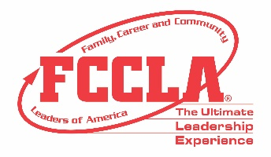
JUSTIFICATION TO ATTEND VIRTUAL NLC LETTER

<Date>

Dear <supervisor's name>,
Our _______ Chapter of Family, Career and Community Leaders of America (FCCLA) has worked diligently this year on learning new concepts in Family and Consumer Sciences. I am requesting your support to obtain financial assistance to attend the FCCLA 2021 Virtual National Leadership Conference (NLC) June 27-July 2, 2021. FCCLA has invested in hosting this hybrid conference on a virtual platform that will provide attendees an opportunity to participate in leadership sessions and career exploration opportunities. FCCLA’s annual National Leadership Conference is the largest national gathering of Family and Consumer Sciences professionals and students across America.

In addition to the presentations and training available for the youth attendees, the conference also offers advisers a comprehensive professional development experience to enhance classroom instruction through engaging sessions on a variety of topics with expert speakers, best practices sessions, and networking opportunities. Hosted by National FCCLA, conference sessions will be presented by subject-matter experts, current on educational trends and needs with a variety of backgrounds in communications, marketing, education, and business. The knowledge and skills I will acquire from professional development will be applicable to current projects such as <current projects unique to your institution, mission, and objectives> Continuing Education Unit (CEU) credits will be offered and awarded to participants completing all professional learning activities. The CEU credit can be applied to my professional development requirements.
The following is an estimate of our virtual attendance registration: <Insert cost here>

I believe this is a great investment in our students as well as my professional development and hope you agree by supporting our request for financial support. It is an honor to have the opportunity to represent our state and school at this national event. We are committed to using our time at Virtual NLC to learn, grow, and explore FCCLA’s four Career Pathways of Education and Training, Visual Arts and Design, Human Services, and Hospitality and Tourism. Thank you for your consideration in supporting our FCCLA chapter’s attendance at this important professional and leadership development conference. Please let me know if you need additional information to provide financial assistance for this event.

Sincerely,

<your name here>

