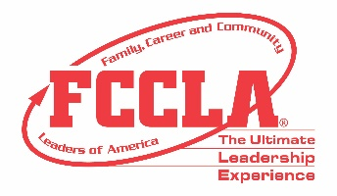
JUSTIFICATION TO ATTEND LETTER

<Date>

Dear <supervisor's name>,
Our _______ Chapter of FCCLA has worked this year on learning new concepts in Family and Consumer Sciences. I would like to request your support in obtaining financial assistance to attend the FCCLA National Fall Conference (NFC) in Columbus, Ohio, November 11-13, 2022. NFC is a student leadership conference with an expected attendance of over 2,000 middle school and high school students and their Family and Consumer Sciences educators. Youth and educators will engage in career pathway focused workshops and training opportunities as well as network opportunities with peers from across the country.

The National Fall Conference also offers advisers a comprehensive educational experience to enhance classroom instruction through engaging sessions on a variety of topics with expert speakers, best practices sessions and networking opportunities. Facilitated by FCCLA, conference sessions will be presented by subject-matter experts, current on educational trends and needs with a variety of backgrounds in communications, marketing, education, and business. The knowledge and skills I will acquire from professional development will be applicable to current projects such as: <Insert current projects unique to your institution, mission, and objectives> Continuing Education Unit (CEU) credits will be offered and awarded to participants completing all professional learning activities.
The following is an estimate of our costs:
Registration: <$xxxx>
Roundtrip Airfare: <$xxxx>
Motor Coach Transportation: <$xxxx>
Ground Transportation: <$xxxx>
Hotel: <$xxxx >
Meals: <$xxxx>

Workshop topics, session format, and the tentative meeting agenda are provided on the attached documentation. I believe this is a great investment in our students and myself and hope you agree by supporting our request for financial support. Thank you for your consideration in supporting our FCCLA chapter’s attendance at this important professional development conference. Please let me know if you need additional information to provide financial assistance for this event.

Attachment: FCCLA National Fall Conference Schedule of Events
Sincerely,
<Insert your name here>

