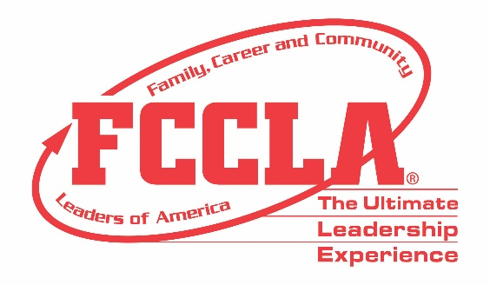

FOR IMMEDIATE RELEASE Contact: Your Name and Title
Phone: Your Phone
Email: Your Email
FCCLA Member(s) Selected to Attend Exclusive Cameron Mitchell Restaurant Experience
(Insert a photo of Member(s))
Columbus, OH, November 2022 – (Insert Student(s) Name(s)) from (Insert Chapter/School Name) was/were among 22 Family, Career and Community Leaders of America (FCCLA) members selected to attend a private tour of the award-winning Cameron Mitchell Restaurant (CMR) Company corporate office. During the tour, attendees heard from the CMR company's executive team. They had the unique opportunity to sit down to lunch with Restauranteur Cameron Mitchell for a private meet-and-greet.
Members traveled to Columbus, Ohio, for the 2022 FCCLA National Fall Conference (NFC), where over 1,200 attendees from across the nation gathered to hear from industry experts, engage in leadership workshops, network with peers, and explore career pathways in Human Services, Hospitality and Tourism, Education and Training, and Visual Arts and Design.
“(Insert quote from a student about CMR Company tour experience overall),” said (Insert Student’s Name and officer position, if any).
FCCLA collaborates with partners to provide opportunities for members to demonstrate college- and career-ready skills in Family and Consumer Sciences and related occupations. This exclusive experience provided FCCLA members with an in-depth industry immersion experience in the Hospitality and Tourism sector.
About FCCLA
Family, Career and Community Leaders of America (FCCLA) is a dynamic and effective student-led nation-based organization supporting youth on their journey to become the leaders of tomorrow and helping them address important personal, family, work, and societal issues through Family and Consumer Sciences education. FCCLA has over 199,200 members and more than 4,900 chapters from 47 state associations and Puerto Rico.
FCCLA: The Ultimate Leadership Experience is unique among youth organizations because its programs are planned and run by members. It is the only career and technical intracurricular student organization with a central focus on careers that support families. Participation in national FCCLA programs and chapter activities aids members in becoming strong leaders in their families, careers, and communities.
###

