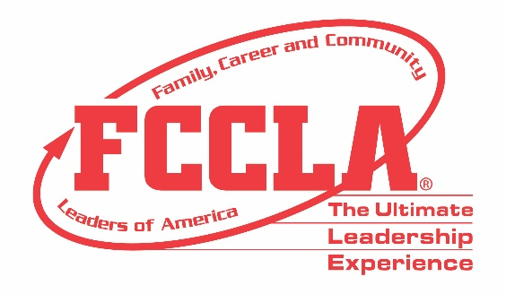

FOR IMMEDIATE RELEASE Contact: Your Name and Title
Phone: Your Phone
Email: Your Email
(Insert Chapter/School Name) Students Make Career Preparation Count in Columbus, OH
Columbus, OH, November (Insert Date), 2022 – (Insert Student(s) Name(s)) from (Insert Chapter/School Name) attended the Family, Career and Community Leaders of America (FCCLA) 2021 National Fall Conference (NFC) in Columbus, OH, November 11-13. FCCLA’s 2022 NFC drew over 1,200 members, advisers, and supporters from across the nation with opportunities for personal development, career exploration, and community service.
Throughout NFC, attendees heard from high-level industry experts. Keynote speakers included Cameron Mitchell, Founder and CEO of Cameron Mitchell Restaurants, Sergeant Major of the US Army Michael Grinston, Newscaster Dom Tiberi, and Olympian Sarah Wells. Before the conference, students competed virtually in career-focused Skill Demonstration Events testing their knowledge in personal finance, consumer responsibilities, technology, health and safety, and more. FCCLA members also networked with fellow youth leaders and learned more about future career and college options through career pathway exploration in Human Services, Hospitality and Tourism, Education and Training, and Visual Arts and Design.
Those in attendance at NFC exemplified FCCLA’s annual theme, “IncREDible,” and shared how they utilize the skills, experiences, and knowledge gained through FCCLA to make a difference in their families, careers, and communities. (Insert Attendee Name and FCCLA Position) said, “(Insert Quote reflecting on National Fall Conference experience).”
About FCCLA
Family, Career and Community Leaders of America (FCCLA) is a dynamic and effective student-led nation-based organization supporting youth on their journey to become the leaders of tomorrow and helping them address important personal, family, work, and societal issues through Family and Consumer Sciences education. FCCLA has over 199,200 members and more than 4,900 chapters from 47 state associations and Puerto Rico.
FCCLA: The Ultimate Leadership Experience is unique among youth organizations because its programs are planned and run by members. It is the only career and technical intracurricular student organization with a central focus on careers that support families. Participation in national FCCLA programs and chapter activities aids members in becoming strong leaders in their families, careers, and communities.
###

