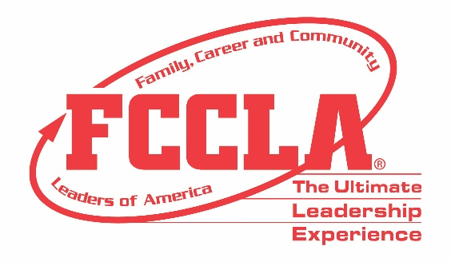

FOR IMMEDIATE RELEASE Contact: Your Name and Title
Phone: Your Phone
Email: Your Email
16 FCCLA/LifeSmarts Knowledge Bowl Teams Qualify to Compete at
2022 National Leadership Conference
Columbus, Ohio (November 11-13, 2022) – More than 1,200 attendees from across the country traveled to Columbus, Ohio, November 11-13, for the Family, Career and Community Leaders of America (FCCLA) 2022 National Fall Conference (NFC). In addition to hearing from keynote speakers, engaging in leadership workshops, and participating in a community service project, 35 teams competed in FCCLA/LifeSmarts Knowledge Bowl.
FCCLA/LifeSmarts Knowledge Bowl is a team competition that challenges students’ knowledge in six content areas: personal finance, consumer rights and responsibilities, technology, health and safety, environment, and FCCLA knowledge. Members participated in both online and on-site levels of competition. Among the top 40 teams nationwide that competed in the FCCLA/LifeSmarts Knowledge Bowl, 16 teams qualified to compete for the National FCCLA/LifeSmarts Championships.
Congratulations to the FCCLA/LifeSmarts National Championship qualifiers:

- East Central FCCLA, Indiana
- Woodford County High School FCCLA 1, Kentucky
- Woodford County High School FCCLA 2, Kentucky
- Woodford County High School FCCLA 3, Kentucky
- Bison 5 – Buffalo High School, Missouri
- Reindeer Smarties Clarkton School FCCLA, Missouri
- Tiger Ambush – Clearwater High School, Missouri
- Butler Tech Ross High School, Ohio
- WCHS FCCLA, South Dakota
- WSHA Senior FCCLA, South Dakota
- Bradford FCCLA, Tennessee
- Bartlett FCCLA, Texas
- HVHA FCCLA, Virginia
- Manor – Manor High School FCCLA, Virginia
- Page County FCCLA, Virginia
- Selah Gold – Selah FCCLA, Washington

While at NFC, FCCLA members also received the opportunity to network with other youth leaders and learn more about future career and college options by exploring FCCLA’s four Career Pathways of Human Services, Hospitality and Tourism, Education and Training, and Visual Arts and Design.
All FCCLA/LifeSmarts Knowledge Bowl competitors and NFC participants returned home with improved knowledge and skills to better prepare them for their future college and career endeavors. The 16 FCCLA/LifeSmarts National Championship qualifiers will compete at FCCLA’s National Leadership Conference in Denver, Colorado, July 2-6, 2023.
About FCCLA
Family, Career and Community Leaders of America (FCCLA) is a dynamic and effective student-led nation-based organization supporting youth on their journey to become the leaders of tomorrow and helping them address important personal, family, work, and societal issues through Family and Consumer Sciences education. FCCLA has over 199,200 members and more than 4,900 chapters from 47 state associations and Puerto Rico.
FCCLA: The Ultimate Leadership Experience is unique among youth organizations because its programs are planned and run by members. It is the only career and technical intracurricular student organization with a central focus on careers that support families. Participation in national FCCLA programs and chapter activities aids members in becoming strong leaders in their families, careers, and communities.
###

