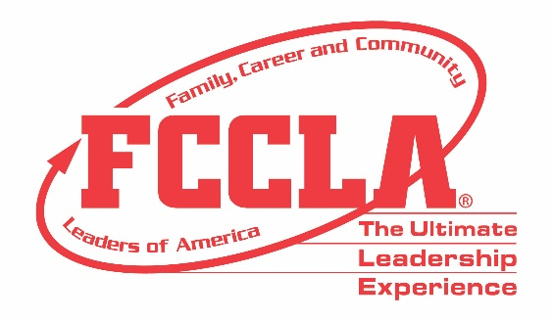

FOR IMMEDIATE RELEASE Contact: Your Name and Title
Phone: Your Phone
Email: Your Email
(Name of School) Students Compete in Knowledge Bowl at FCCLA National Fall Conference
(Insert a photo of the Knowledge Bowl team)
Columbus, Ohio, November 11-13, 2022 – (Insert Student(s) Name(s)) from (Insert Chapter/School Name) joined over 1,200 members, advisers, and advocates at the Family, Career and Community Leaders of America (FCCLA) 2022 National Fall Conference (NFC) in Columbus, OH, November 11-23, 2022.
During NFC, (Insert Students Names) competed in the FCCLA/LifeSmarts Knowledge Bowl Competitive Event. The FCCLA/LifeSmarts Knowledge Bowl is a team competition that challenges students’ knowledge in six content areas: personal finance, consumer rights and responsibilities, technology, health and safety, environment, and FCCLA knowledge. Members participated in both online and on-site levels of competition. (Insert Chapter Name) placed (Insert Place) among 40 teams from across the nation at FCCLA’s 2022 NFC.
In addition, NFC provided (Name of School) chapter members with the opportunity to hear from keynote speakers, engage in leadership workshops, participate in a community service project, and more. FCCLA members also received the opportunity to network with other youth leaders and learn more about future career and college options through exploring the career pathways of Human Services, Hospitality and Tourism, Education and Training, and Visual Arts and Design.
“(Insert quote from a student about Knowledge Bowl competition and FCCLA NFC overall),” said (Insert Student’s Name and officer position, if any).
All FCCLA/LifeSmarts Knowledge Bowl competitors and NFC participants returned home with improved knowledge and skills to better prepare them for their future college and career endeavors. The top 16 highest-scoring FCCLA/LifeSmarts Knowledge Bowl teams will advance to compete at the 2023 FCCLA National Leadership Conference, Denver, CO, July 2-6, 2023.
About FCCLA
Family, Career and Community Leaders of America (FCCLA) is a dynamic and effective student-led nation-based organization supporting youth on their journey to become the leaders of tomorrow and helping them address important personal, family, work, and societal issues through Family and Consumer Sciences education. FCCLA has over 199,200 members and more than 4,900 chapters from 47 state associations and Puerto Rico.
FCCLA: The Ultimate Leadership Experience is unique among youth organizations because its programs are planned and run by members. It is the only career and technical intracurricular student organization with a central focus on careers that support families. Participation in national FCCLA programs and chapter activities aids members in becoming strong leaders in their families, careers, and communities.
###

