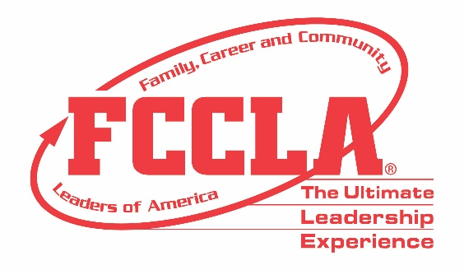

**FOR IMMEDIATE RELEASE**  **Contact:** *Your Name and Title*

**Phone:** *Your Phone*

**Email:** *Your Email*

**Thousands of Youth Leaders Attend FCCLA National Fall Conference**

**Columbus, OH –** From managing personal finances to succeeding in their chosen career, many young adults feel underprepared to contribute to the workforce meaningfully. Family, Career and Community Leaders of America ([**FCCLA**](http://fcclainc.org/)) prepares today’s youth for this transition. FCCLA student members earn access to numerous learning opportunities, gain confidence in their life skills, and develop employability skills to fill workforce needs. These skills range from communication and problem-solving to teamwork and leadership.

Over 1,200 middle and high school students and educators joined in Columbus, OH, November 11-13, 2022, to exemplify the Ultimate Leadership Experience. Equipped with life skills learned through Family and Consumer Sciences (FCS) education and leadership skills gained from involvement in FCCLA, conference attendees prepare to enter college and careers with skills and experiences to them up for success.

Traveling from across the nation to attend National Fall Conference (NFC), FCCLA members strengthen leadership skills, explore Career Pathways, and receive hands-on experience through participating in Skill Demonstration Events. Participants will also have an opportunity to hear from numerous high-level speakers such as Cameron Mitchell, Founder and CEO of Cameron Mitchell Restaurants, Sgt. Major of the U.S. Army Michael Grinston, Newscaster Dom Tiberi, and Olympian Sarah Wells.

Regardless of path or profession, FCCLA provides members with fundamental world skills, education, and life experiences to last a lifetime. With a rich organizational history of nearly 77 years and more than 10 million alumni, FCCLA members continue to change the world and set the bar for the next generation’s leaders.

***About FCCLA***

*Family, Career and Community Leaders of America (FCCLA) is a dynamic and effective student-led national organization that supports youth on their leadership journey. FCCLA helps students address important personal, family, work, and societal issues through Family and Consumer Sciences education. FCCLA has over 199,200 members and more than 4,900 chapters from 47 state associations and Puerto Rico.*

***FCCLA:*** *The Ultimate Leadership Experience is unique among youth organizations because its programs are planned and run by members. It is the only career and technical intracurricular student organization with a central focus on careers that support families. Participation in national FCCLA programs and chapter activities aids members in becoming strong leaders in their families, careers, and communities.*

*###*