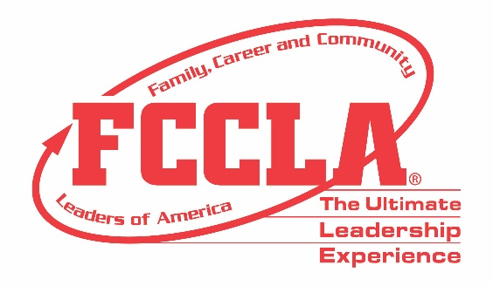

FOR IMMEDIATE RELEASE Contact: Your Name and Title
Phone: Your Phone
Email: Your Email
(Name of School) Students Competed in Skill Demonstration Events at FCCLA National Fall Conference
(Insert a photo of the Skill Demonstration Event team)
Columbus, OH, November 11-13, 2022 – (Insert Student(s) Name(s)) from (Insert Chapter/School Name) traveled to Columbus, Ohio, November 11-13, 2022, for the 2022 Family, Career and Community Leaders (FCCLA) National Fall Conference (NFC). Over 1,200 attendees from across the nation gathered to hear from industry experts, engage in leadership workshops, network with peers, and explore career pathways in Human Services, Hospitality and Tourism, Education and Training, and Visual Arts and Design.
In addition, (Insert Students Names) represented (Insert Chapter/School Name) at NFC by competing in the (Insert Event Name) Skill Demonstration Event. Skill Demonstration Events provide opportunities for members to demonstrate college- and career-ready skills in Family and Consumer Sciences and related occupations. Over 375 students participated in the Skill Demonstration Events Competitions and (Insert Student(s) Name(s)) from (Insert School Name) in (Insert City Name) placed (Insert Place) in the nation.
“(Insert quote from a student about Skill Demonstration Event competition and his/her FCCLA NFC experience overall),” said (Insert Student’s Name and officer position, if any).
Attending NFC and participating in Competitive Events such as Skill Demonstration Events equips students with the tools, knowledge, and opportunities needed to be college- and career-ready. Members utilize the skills learned and experiences gained through FCCLA to improve their families, careers, and communities.
About FCCLA
Family, Career and Community Leaders of America (FCCLA) is a dynamic and effective student-led nationwide organization supporting youth on their leadership journey by helping them address important personal, family, work, and societal issues through Family and Consumer Sciences education. FCCLA has over 199,200 members and more than 4,900 chapters from 47 state associations and Puerto Rico.
FCCLA: The Ultimate Leadership Experience is unique among youth organizations because its programs are planned and run by members. It is the only career and technical intracurricular student organization with a central focus on careers that support families. Participation in FCCLA programs and chapter activities aids members in becoming strong leaders in their families, careers, and communities.
###

