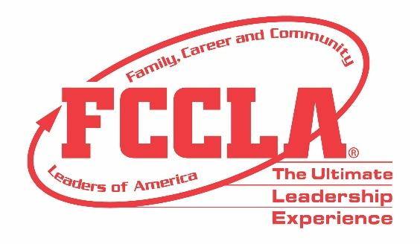

**FOR IMMEDIATE RELEASE Contact:** *Your Name and Title*

**Phone:** *Your Phone*

**Email:** *Your Email*

*(Insert Chapter/School Name)* **FCCLA National Fall Conference Inspires Student Leadership for an Unforgettable Journey!**

**Birmingham, Alabama - November 10-12*,* 2023 –** Journeying from *(Insert Chapter/School Name), (Insert Student(s) Name(s))* attended an enriching experience at the 2023 Family, Career and Community Leaders of America (FCCLA) National Fall Conference (NFC) in Birmingham, Alabama, on November 10-12. Drawing over 1,400 members, advisers, and supporters from across the nation, FCCLA’s 2023 NFC was a catalyst for personal development, career exploration, and community service.

Throughout NFC, attendees heard inspiring stories from keynote speakers, including Monti Washington, Joshua Evans, and a captivating session led by Brent Camalich from Dude. Be Nice. Students competed in career-focused Skill Demonstration Events showcasing their readiness for college and careers in Family and Consumer Sciences and related fields. Prior to the conference, students competed virtually, testing their knowledge in personal finance, consumer responsibilities, technology, health and safety.

Beyond competitions, FCCLA Members engaged in youth leadership workshops and also participated in a screening of the film, ‘One Small Visit’, a captivating 30-minute film about the incredible true story of an immigrant Indian family who unexpectedly passes through the Midwest hometown of Neil Armstrong amidst the backdrop of the 1969 moon landing. The screening culminated in an enriching panel discussion with the film’s writer and producers. FCCLA Advisers now have the opportunity to bring this film to their classroom along with the panel discussion and a comprehensive lesson plan, which all act as powerful tools for nurturing a sense of community and inspiring students to share their own stories.

Those in attendance at NFC exemplified FCCLA’s annual theme, “**The Ultimate Journey**,” and shared how they utilize the skills, experiences, and knowledge gained through FCCLA to make a difference in their families, careers, and communities. Reflecting on the National Fall Conference experience, (*Insert Attendee Name and FCCLA Position*) said, “(*Insert Quote reflecting on National Fall Conference experience*).”

***About FCCLA***

*Family, Career and Community Leaders of America (FCCLA) is a dynamic and effective student-led nation-based organization supporting youth on their journey to become the leaders of tomorrow and helping them address important personal, family, work, and societal issues through Family and Consumer Sciences education. FCCLA has over 237,000 members and more than 5,100 chapters from 47 state associations and Puerto Rico.*

***FCCLA:*** *The Ultimate Leadership Experience is unique among youth organizations because its programs are planned and run by members. It is the only career and technical intracurricular student organization with a central focus on careers that support families. Participation in National FCCLA programs and chapter activities aids members in becoming strong leaders in their families, careers, and communities.*

*###*