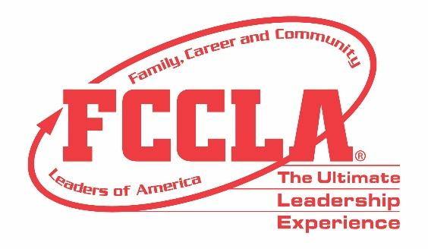

**FOR IMMEDIATE RELEASE**  **Contact:** *Your Name and Title*

**Phone:** *Your Phone*

**Email:** *Your Email*

**Navigating 'The Ultimate Journey' towards Career Excellence**

*(Insert Photo of Students at NFC)*

**Birmingham, Alabama - November 10-12, 2023 –** Over 1,400 attendees from across the country traveled to Birmingham, Alabama, November 10-12, 2023, for Family, Career and Community Leaders of America (FCCLA) 2023 National Fall Conference (NFC). The conference theme, ‘The Ultimate Journey,’ offered FCCLA members opportunities to strengthen leadership skills, explore Career Pathways, and compete in Skill Demonstration Events showcasing their readiness for college and careers in Family and Consumer Sciences and related fields. Prior to the conference, students competed virtually, testing their knowledge in personal finance, consumer responsibilities, technology, health, and safety.

Members were inspired by keynote speakers who shared their achievements and the invaluable lessons drawn from their personal journeys. They also participated in a screening of the film, ‘One Small Visit,’ a captivating 30-minute film about the incredible true story of an immigrant Indian family who unexpectedly passes through the Midwest hometown of Neil Armstrong amidst the backdrop of the 1969 moon landing. The screening culminated in an enriching panel discussion with the film’s writer and producers.

"FCCLA guides students on 'The Ultimate Journey' toward their future careers," Sandy Spavone, Executive Director of FCCLA, emphasized. "By diving into competitions, embracing leadership training, mastering employability skills, and networking, FCCLA members are equipped with the essential tools for success in today’s world."

By attending conferences, FCCLA members experience a new city’s culture, empowering them to bring their knowledge home to share with their families, chapters, and communities. FCCLA will be hosting its annual national conference in Seattle, Washington, June 29-July 3, 2024, with more than 7,000 members, advisers, and supporters expected to attend.

***About FCCLA***

*Family, Career and Community Leaders of America (FCCLA) is a dynamic and effective student-led nation-based organization supporting youth on their journey to become the leaders of tomorrow and helping them address important personal, family, work, and societal issues through Family and Consumer Sciences education. FCCLA has over 237,000 members and more than 5,100 chapters from 47 state associations and Puerto Rico.*

***FCCLA:*** *The Ultimate Leadership Experience is unique among youth organizations because its programs are planned and run by members. It is the only career and technical intracurricular student organization with a central focus on careers that support families. Participation in national FCCLA programs and chapter activities aids members in becoming strong leaders in their families, careers, and communities.*

*###*