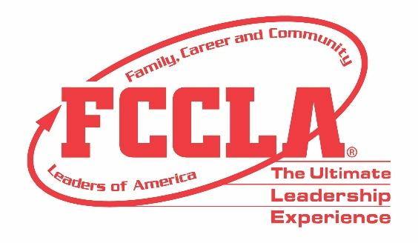

**FOR IMMEDIATE RELEASE**  **Contact:** *Your Name and Title*

**Phone:** *Your Phone*

**Email:** *Your Email*

**16 FCCLA/LifeSmarts Knowledge Bowl Teams Qualify to Compete at 2024 National Leadership Conference**

**Birmingham, Alabama (November 10-12, 2023) –** More than 1,400 attendees from across the country traveled to Birmingham, Alabama on November 10-12, for the Family, Career and Community Leaders of America (FCCLA) 2023 National Fall Conference (NFC). In addition to hearing from keynote speakers, engaging in leadership workshops, and participating in a community service project, 35 teams competed in FCCLA/LifeSmarts Knowledge Bowl.

FCCLA/LifeSmarts Knowledge Bowl is a team competition that challenges students’ knowledge in six content areas: personal finance, consumer rights and responsibilities, technology, health and safety, environment, and FCCLA knowledge. Members participated in both online and on-site levels of competition. Among the top 40 teams nationwide that competed in the FCCLA/LifeSmarts Knowledge Bowl, 16 teams qualified to compete for the National FCCLA/LifeSmarts Championships.

Congratulations to the FCCLA/LifeSmarts National Championship qualifiers:

* Bartlett FCCLA, Texas
* Brownsboro High School, Texas
* Butler County FCCLA, Kentucky
* Butler Tech Ross High School, Ohio
* Clark Senior FCCLA, South Dakota
* Cleburne County High School, Alabama
* East Central FCCLA, Indiana
* Grayson County High, Kentucky
* Halifax County High Kentucky
* John P. Stevens FCCLA, New Jersey
* Junction City High School FCCLA, Kansas
* Leonard High School FCCLA, Texas
* Mason County High School, Kentucky
* Selah High School FCCLA, Washington
* Stamford FCCLA, Texas
* West Lyon FCCLA, Iowa

All FCCLA/LifeSmarts Knowledge Bowl competitors and NFC participants returned home with improved knowledge and skills to better prepare them for their future college and career endeavors. The 16 FCCLA/LifeSmarts National Championship qualifiers will compete at FCCLA’s National Leadership Conference in Seattle, Washington, June 29 – July 3, 2024.

***About FCCLA***

*Family, Career and Community Leaders of America (FCCLA) is a dynamic and effective student-led nation-based organization supporting youth on their journey to become the leaders of tomorrow and helping them address important personal, family, work, and societal issues through Family and Consumer Sciences education. FCCLA has over 237,000 members and more than 5,100 chapters from 47 state associations and Puerto Rico.*

***FCCLA:*** *The Ultimate Leadership Experience is unique among youth organizations because its programs are planned and run by members. It is the only career and technical intracurricular student organization with a central focus on careers that support families. Participation in national FCCLA programs and chapter activities aids members in becoming strong leaders in their families, careers, and communities.*

*###*