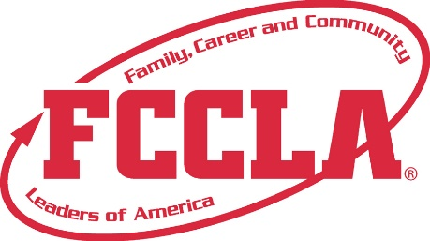

**FOR IMMEDIATE RELEASE**  **Contact:** *(Name, Title)*

**Phone:** *(Phone)*

**Email:** *(Email)*

***(Insert Chapter’s Name) Shines at FCCLA National Leadership Conference in Denver, CO, July 2-6***

*[Insert photo of Chapter members here]*

***Denver, CO, July 2023*** *– (Insert Chapter’s Name) FCCLA proudly represented their school and community at the highly anticipated FCCLA National Leadership Conference (NLC) held at the Colorado Convention Center from July 2-6. This annual event brought together more than 7,900 passionate Family, Career and Community Leaders of America (FCCLA) student members, advisers, and guests.*

*The conference provided (chapter name) FCCLA members with a wealth of incredible opportunities, including attending inspiring speaker sessions, engaging in youth workshops, competing on a national level, and networking with fellow youth leaders. Centered around the theme "incREDible," this conference highlighted how FCCLA offers incredible prospects to its members and advisers through Family and Consumer Sciences (FCS) education. By exploring career opportunities and instilling real-world skills, advocacy, and service, FCCLA empowers its members to make an incREDible impact that will guide them throughout their lives.*

*Sandy Spavone, Executive Director of Family, Career and Community Leaders of America, expressed her enthusiasm, stating, "We are thrilled to have welcomed over 7,900 members, advisers, corporate partners, and guests who are dedicated to discovering the unlimited possibilities available through FCCLA. The relationships and skills developed during this conference have inspired students to make an incREDible difference in their communities."*

*During the conference, (Insert Names of Students Who Attended NLC) showcased their exceptional talent and dedication by participating in various events. Their remarkable achievements are a testament to their hard work, determination, and the guidance of their advisers.*

*The results of their participation are as follows: (Include List of Events Students Competed in and Places Awarded, Offices Served, or Workshops Attended).*

*Looking ahead, FCCLA will be hosting its next National Leadership Conference in Seattle, WA from June 29 to July 3, 2024. For those interested in getting involved as a student, sponsor, or supporter, please contact (Insert Adviser’s Name) at (Insert School’s Name).*

**About FCCLA**

Family, Career and Community Leaders of America (FCCLA) is a dynamic and effective student-led nation-based organization supporting youth on their journey to become the leaders of tomorrow and helping them address important personal, family, work, and societal issues through Family and Consumer Sciences education. FCCLA has over 237,000 members and more than 5,100 chapters across the nation.

FCCLA: The Ultimate Leadership Experience is unique among youth organizations because its programs are planned and run by members. It is the only career and technical intracurricular student organization with a central focus on careers that support families. Participation in national FCCLA programs and chapter activities aids members in becoming strong leaders in their families, careers, and communities.

For more information on FCCLA, please contact *(Insert adviser Name)* at *(School Phone Number)* or *(Email Address).*

###