- Log in to the FCCLA Adviser Portal
  - Visit the FCCLA Adviser Portal: https://affiliation.registermychapter.com/fccla#
  - The unique 5-digit chapter ID assigned to your chapter will be your username. Select the Forgot Username button should you forget your chapter ID, and your chapter ID will be emailed to the email address associated with your profile.
  - Your password is something you have created. Select the Forgot Password button to have your username and password emailed to you.
  - For assistance resetting your credentials, please contact your FCCLA State Adviser.
- Upon logging into the Adviser Portal for the first time, you are prompted to complete a landing page to verify and update important information. Please confirm the following fields:

FCCLA Chapter Adviser Landing Page

Cell Phone and Email: Please update or review your cell phone number and email address. To confirm your email address, please select the checkbox to the right of the email field.
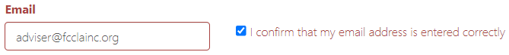

Chapter Adviser Status: Please review and update the status of Chapter Advisers in your chapter. This question will only appear if your chapter has more than one active adviser.

A blue checkmark icon symbolizes an “active” status. To make an adviser “inactive,” select the blue checkmark icon to the right of their name and confirm the prompt. The checkmark icon will appear as a crossed-through circle once an adviser is made inactive.
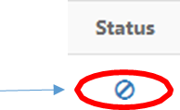
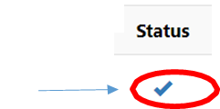

Making an adviser inactive removes their ability to log into the chapter and ensures that your chapter is not charged adviser dues for that individual.

Primary Chapter Status: Chapter Advisers may advise multiple chapters. A Chapter Adviser’s “primary” chapter must be set for reporting purposes. If you advise in multiple chapters, this will not change your status in your other chapters. Advisers whose profile is linked to only one chapter may proceed to the next question. In this instance, the chapter listed will be preselected as your primary chapter.

If you see a chapter listed here that you no longer advise in, please select the blue checkmark icon to the far right of the chapter name under the Status column, then confirm the prompt. This will make your profile inactive in that chapter. If you actively advise in multiple chapters, you should see them listed here and should keep your status the same. If you currently advise in another chapter you do not see listed, please contact your State Adviser for assistance linking your adviser profile to that chapter.
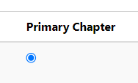
Next, indicate the chapter you wish to designate as your “primary” chapter by selecting the icon under the Primary Chapter column.

Only one chapter may have this designation, but designating a chapter as your “primary” chapter will not affect other chapters you advise in.

Education and Training: Use the dropdown arrow to select the option most aligned with your education and training background.

Former FCCLA/FHA/HERO Member: Use the dropdown arrow to indicate if you are a former member.

FCCLA Career Pathways: Indicate each FCCLA Career Pathway that you teach by selecting the checkbox icon to the left of each Career Pathway. Select all that apply. For examples of topics that align with each pathway, select the information bubble to the right of the Career Pathway. For more information, visit the Career Pathways page of the FCCLA website.

Principal’s Information: Please review your principal’s first name, last name, and email address.

Membership Package Enrollment: If your FCCLA State Association currently offers one or both Membership Packages, you will be asked to select the Membership Package you wish to enroll in.

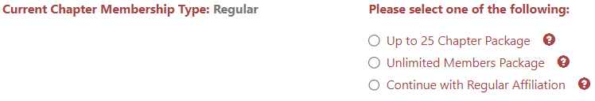

Note: If your chapter was previously affiliated using Middle-Level, Post-Secondary, or Urban membership, you will not see this question appear. Chapters in states that do not currently offer Membership Package options will not see this question.

To learn more about FCCLA’s Membership Packages, please select the information bubble next to each membership type, or visit the Membership Packages page of the FCCLA’s website. To confirm if your state offers Membership Packages and review their associated cost, please visit the Membership Packages State Rate Breakdown resource on the FCCLA website’s Membership Packages page, or contact your FCCLA State Adviser.

Graduation Preferences: Select your chapter's highest possible grade level using the dropdown arrow. Then, choose one of the following options on how to treat your graduating members:
- Graduated Students Will All Move Onto The Same Chapter – This selection is appropriate if all of the students that graduate from your chapter will move onto the same school and FCCLA chapter upon graduating.
- Graduated Students Will Move Onto Various Chapters – This selection is appropriate if graduated students move onto various schools and chapters. This is most common for middle school chapters whose students will enroll in various high schools/chapters after completing middle school.
- Eligible for Alumni & Associates – This selection is for 12th-grade students that will graduate from your chapter. This is appropriate if your chapter’s highest possible grade level is 12th. Recent graduates are welcome and encouraged to join FCCLA’s Alumni & Associates group to stay connected with FCCLA.

County: Select the county that your school is located in using the dropdown arrow.

Membership Increase Goal: Set a membership increase goal for your chapter by entering a numeric value representing the number of new members you wish to see your chapter gain this school year.

- After updating your chapter’s landing page information, select the black Confirm button to submit your responses.

- If your FCCLA State Association has a questionnaire set up, you may be required to answer state-specific questions.

- Once you’ve entered your chapter, review and close any applicable pop-up messages, then select the red Graduate button under the Members tab toward the top left of the page.

- Members who have moved on from your school/chapter in the previous year should be graduated from your chapter during this step. Members can be selected individually using the checkbox icon to the left of their name or all at once by clicking the black Select All button toward the left of the page.
  - Graduated Students Will All Move Onto The Same Chapter – Under the Graduating School column, you will see the new chapter that members will transfer to upon completing this step.
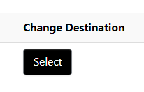
  - Graduated Students Will Move Onto Various Chapters – Using the black Select button under the Change Destination column, select the chapter each member should graduate into. First, choose the city where their new chapter is located, then select the specific chapter the member will join. Your selection will determine the chapter that each member’s profile will appear in once this step has been completed.
  - Eligible for Alumni & Associates – Enter members’ emails in the Post-Graduation Emails column. FCCLA will use these emails to share news about FCCLA happenings and encourage graduates to use their graduate discount to become FCCLA Alumni & Associates members.

To finish this step, select the black Graduation Completed button, then select Yes in the prompt, indicating you confirm changes and have finished the graduation process.

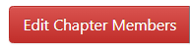
- Completing the graduation process will return you to the member roster under the Members tab. From here, select the red Edit Chapter Members button toward the top left of the page.

- Review existing members’ information and update the Member Title, Demographic, Email, and Cell Phone fields as needed. Member grade levels will reflect the grade they completed in the prior year.

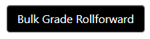
For your convenience, all member grades may be updated to increase by one grade level by using the black Bulk Grade Rollfoward button. Select this button, then Confirm the pop-up message to finalize changes.

If a member should be removed from your roster, select the checkbox in the Delete column to the far left of their name, then scroll to the bottom of the page and select the red Delete Selected Students button. Select Confirm to save changes.

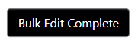
If you have finished editing your chapter’s existing members, select the black Bulk Edit Complete button at the bottom right of the page. To complete this step, select Yes in the pop-up message.
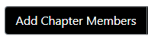
- To add new members to your FCCLA Chapter, select the black Add Chapter Members button and select one of the following member upload methods.
  - Individual Member Entry
- Select the accordion to expand it.
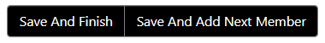
- Fields outlined in red are required. Enter all required fields for your member, then select Save And Add Next Member to remain here and continue to members, or select Save And Finish to be brought back to your chapter roster under the Members tab. Either selection will save the new member to your chapter roster.

- Bulk CSV Upload **Recommended when planning to enter many students
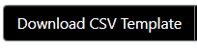
  - Select the accordion to expand it, then select the black Download CSV Template button.
  - Input required member information (first name, last name, grade, gender, demographic, member title, email, and cell phone) onto the CSV Template. Required information must be input precisely to ensure the Portal correctly processes your new members. To review the required fields and the selections for Gender, Demographic, or Member Title, please check the Member Affiliation Info Form in the Resources section of the Chapter Affiliation page of the FCCLA website.

These fields must be entered and spelled precisely how the Member Affiliation Info Form outlines to be processed successfully. (ex. For gender, “female” must be spelled out and will not be accepted if entered as an abbreviated “F”)

  - Once all information is entered on the CSV Template, FCCLA recommends saving a copy to your computer. Save the template as a CSV file and not an Excel file. To upload the new members on your CSV Template, drag the file into the blue box that says Drag files here.
  - Scroll down to see the list of your new members. Member entries highlighted in red indicate that an error occurred. Their information must be edited using the edit pencil before saving changes. Member entries highlighted in yellow indicate possible duplicate members that you should review. Member entries in white indicate no errors.
  - Scroll up and select the black Save button to add these new members to your FCCLA Chapter.
- Bulk Member CSV Entry
- Select the accordion to expand it. Next, input all required information (first name, last name, grade, gender, demographic, member title, email, and cell phone). Use the drop-down arrows to view the options for each field. Once all data is entered, select the black Save button and save changes by selecting Confirm in the pop-up.

OR

- Download the CSV Template within this accordion and complete the required information in each column for your students. Once all information has been entered into the CSV Template, highlight all member information and use the Ctrl + C function to copy the data. Return to the FCCLA Adviser Portal and place your cursor in the first Prefix box. Use the Ctrl + V function to paste your data into the boxes. Member information should appear in the appropriate columns if all entries were pasted correctly. Select the black Save button and Confirm the pop-up to finalize this step.

Note: The Export Data button will extract the information entered on your screen and download it to your device. This button will not save the members to your roster.

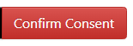
- Return to the Members tab and select the red Confirm Consent button. Confirming consent indicates that you have consent from all students to enter their information into the FCCLA Portal.

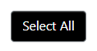
Confirm consent by selecting individual members using the checkbox to the right of their names or the black Select All button to the right of the page. Then, select the black Save button in the bottom left.

- Select members you would like to submit to an affiliation invoice using the black Select All button or individually selecting members using the checkbox to the left of their names under the Select column. All active Chapter Advisers will be automatically included on the chapter’s first affiliation invoice.
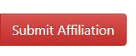
- Select the red Submit Affiliation button to create an affiliation invoice.

If you receive a pop-up message prompting you to Check For Duplicate Names, the Portal has recognized a duplicate member on your roster. To avoid being charged for a duplicate member, review the duplicate profile and select the checkbox under the Remove column to remove the duplicate entry. Then, select Remove and Confirm to save changes.

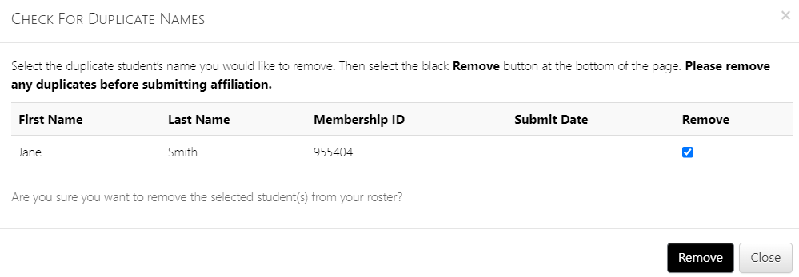

- Please verify that the affiliation amount the Portal has calculated is correct BEFORE selecting the black Create Invoice button.
  - The Export P.O. button will extract the affiliation invoice breakdown displayed on your screen and download it as a PDF to your device. This information may be used for obtaining a purchase order (PO) for your school. Exporting a PO will not create an invoice for your chapter. You must select the Create Invoice button to produce an invoice.

Creating an affiliation invoice does not affiliate your chapter or members. Your chapter and members’ status will change from Pending to Affiliated after payment has been applied to their invoice(s).
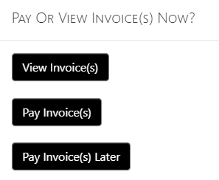
- After selecting Create Invoice, you receive the following options:
  - View Invoice(s) – This will take you directly to your invoice(s), where you can view details and print them.
  - Pay Invoice(s) – This will take you directly to where you can pay invoices using a Credit Card or Remote Check.
  - Pay Invoice(s) Later – This will exit the pop-up and keep you on the Members tab.

