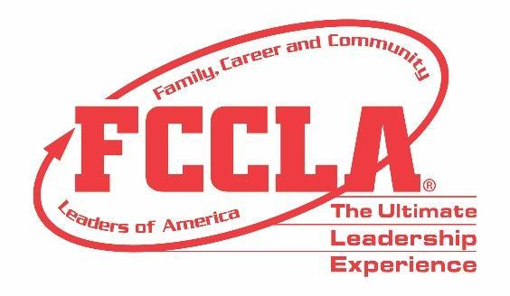

FOR IMMEDIATE RELEASE Contact: Pascale Ghali, Communications Manager
Phone: 703-476-4900
Email: pghali@fcclainc.org

(state) Student Awarded Access Scholarship to 2024 FCCLA National Leadership Conference

Reston, VA – (Student name/high school/ state) has been unanimously selected as one of the three recipients of this year’s Family, Career, and Community Leaders of America (FCCLA) Access Scholarship. They received $5,000 in financial assistance to help offset the cost of attending the 2024 National Leadership Conference (NLC) in Seattle, Washington, from June 29 – July 3, 2024. This new scholarship program is sponsored by the Governor’s Highway Safety Association (GHSA) and Octane Public Relations and was established to provide a life-changing opportunity for the scholarship recipients to attend the NLC along with their chapter adviser.

FCCLA received over 150 applications from 39 states across the country. (Student name)’s entry caught the attention of FCCLA’s Inclusion, Access, Equity, and Diversity (IAED) Committee, the esteemed selection panel for the Access Scholarship. All nationally affiliated student members in good standing were eligible to apply for the 2024 Access Scholarship. The criteria for the scholarship award include financial need, academic merit, community engagement, and school/FCCLA involvement.

“(Student Quote)”

FCCLA hopes that scholarship recipients can apply the skills and knowledge they gain from attending NLC to benefit their careers, FCCLA Chapter, and communities. Congratulations!

About FCCLA
Family, Career, and Community Leaders of America (FCCLA) is a dynamic and effective student-led nation-based organization supporting youth on their journey to become the leaders of tomorrow and helping them address important personal, family, work, and societal issues through Family and Consumer Sciences education. FCCLA has over 240,000 members and more than 5,100 chapters from 47 state associations and Puerto Rico. For more information, visit www.fcclainc.org.

