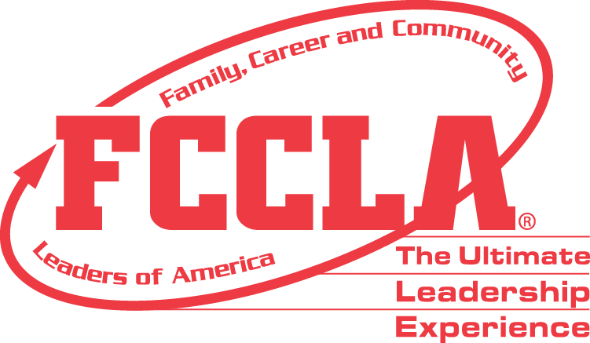

**FOR IMMEDIATE RELEASE** Contact: [NAME]

Phone: [CHAPTER NAME]

Email: [PHONE]

**[CHAPTER NAME] FCCLA Chapter Wins National Facts Project Award**

RESTON, VA— [CHAPTER NAME], [STATE], was selected to receive the 2024 National [1st Place High School **OR** 1st Place Middle School **OR** Runner Up] Families Acting for Community Traffic Safety (FACTS) Award, sponsored by Ford Philanthropy as a program of Family, Career and Community Leaders of America (FCCLA).

FACTS is a national peer-to-peer education program through which students strive to save lives through personal, vehicle, and road safety. The purpose of the FACTS award program is to encourage local chapter members to identify a specific community traffic safety problem and carry out an innovative project to address that need. Using their Family and Consumer Sciences skills, members can take the lead in their communities and show how youth can make a difference.

As the national [1st Place High School **OR** 1st Place Middle School **OR** Runner Up], the [CHAPTER NAME] FCCLA chapter received a [AWARD AMOUNT] award and was recognized at the 2024 FCCLA National Leadership Conference, in Seattle from June 29 - July 3, 2024.

[INSERT PROJECT DESCRIPTION]

**About FCCLA**

Family, Career and Community Leaders of America (FCCLA) is a dynamic and effective student-led nation-based organization supporting youth on their journey to become the leaders of tomorrow and helping them address important personal, family, work, and societal issues through Family and Consumer Sciences education. FCCLA has over 240,000 members and more than 5,200 chapters across the nation.

FCCLA: The Ultimate Leadership Experience is unique among youth organizations because its programs are planned and run by members. It is the only career and technical intracurricular student organization with a central focus on careers that support families. Participation in national FCCLA programs and chapter activities aids members in becoming strong leaders in their families, careers, and communities. For more information on FCCLA, please contact (Insert adviser Name) at (School Phone Number) or (Email Address).

**About Ford Philanthropy**

As the global philanthropic arm of Ford, Ford Philanthropy co-creates and invests in programs that build equity and apply mobility expertise to expand access to essential services, education for the future of work, and entrepreneurship. Founded in 1949, Ford Philanthropy is a not-for-profit organization funded and made possible by Ford Motor Company profits. Although the Ford family founded the Ford Foundation in 1936, Ford Philanthropy and the Ford Foundation are separate entities that operate independently and have no relationship to one another. Ford Philanthropy awards grants to organizations and initiatives that support its philanthropic priorities in communities around the world where Ford operates. For more information, visit: https://www.fordphilanthropy.org/

#####