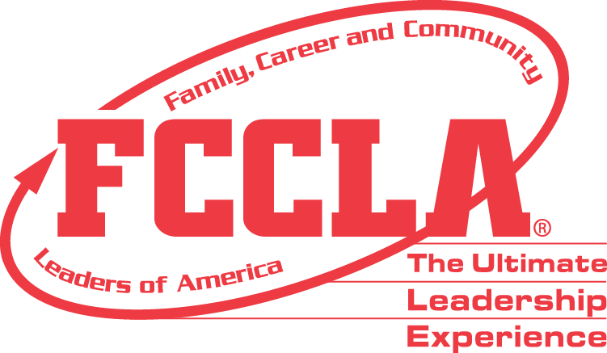

**FOR IMMEDIATE RELEASE** Contact: [NAME]

Phone: [CHAPTER NAME]

Email: [PHONE]

**[Student's Name] Selected for 2024 FCCLA Japanese Exchange Program Scholarship**

[City, State], [Date] — [Student's Name], a dedicated member of Family, Career, and Community Leaders of America (FCCLA) at [High School Name], has been awarded the esteemed 2024 FCCLA Japanese Exchange Program Scholarship. Sponsored by the Kikkoman Corporation and administered by Youth For Understanding USA (YFU), this scholarship is valued at over $9,995.

[Student's Name] will embark on a six-week immersion experience in Japan this summer, where [he/she/they] will live with a host family, participate in cultural activities, and gain invaluable insights into Japanese life and traditions. This unique opportunity promotes international understanding through personal experience, fostering a deeper appreciation of global issues.

"I'm thrilled to have the opportunity to experience Japanese culture firsthand," said [Student's Name]. "This scholarship will allow me to broaden my horizons and create lifelong memories."

The FCCLA Japanese Exchange Program is designed to cultivate personal growth and international understanding. Participants will engage in traditional Japanese customs, such as tea ceremonies, martial arts, and local festivals, providing a comprehensive cultural immersion.

For more information about the FCCLA Japanese Exchange Program and other FCCLA opportunities, please visit fcclainc.org.

**About FCCLA®**

Family, Career and Community Leaders of America (FCCLA) is a dynamic and effective student-led nation-based organization supporting youth on their journey to become the leaders of tomorrow and helping them address important personal, family, work, and societal issues through Family and Consumer Sciences education. FCCLA has over 240,000 members and more than 5,200 chapters across the nation.

The Ultimate Leadership Experience is unique among youth organizations because its programs are planned and run by members. It is the only career and technical intracurricular student organization with a central focus on careers that support families. Participation in national FCCLA programs and chapter activities aids members in becoming strong leaders in their families, careers, and communities. For more information on FCCLA, please contact (Insert adviser Name) at (School Phone Number) or (Email Address).

###