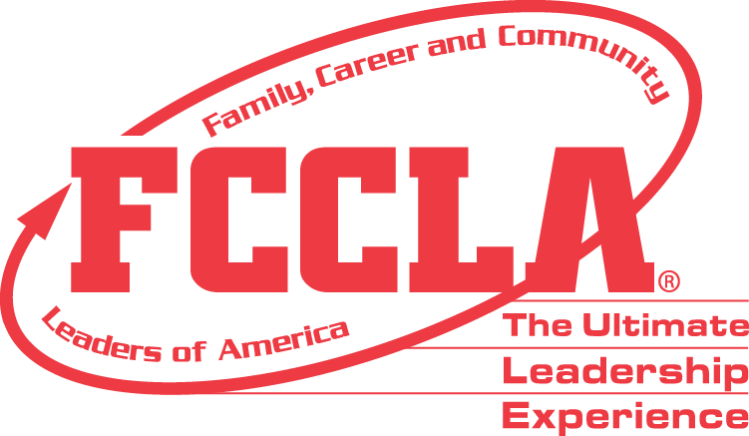

**FOR IMMEDIATE RELEASE** Contact: [NAME]

Phone: [CHAPTER NAME]

Email: [PHONE]

**[Student's Name] Awarded 2024 FCCLA Memorial Scholarship**

[City, State], [Date] — [Student's Name], an exemplary member of Family, Career and Community Leaders of America (FCCLA) at [High School Name], has been awarded the esteemed 2024 FCCLA Memorial Scholarship. This $2,500 scholarship honors the leadership and contributions of past FCCLA Members and Leaders, supporting graduating seniors who demonstrate outstanding leadership and community involvement.

[Student's Name] was selected for [his/her/their] remarkable leadership skills, active participation in community service, and diverse extracurricular activities. The scholarship funds will be disbursed directly to the accredited institution [he/she/they] will be attending in the fall, and can be used for tuition, room, and board expenses.

"I am deeply honored to receive the FCCLA Memorial Scholarship," said [Student's Name]. "This award will significantly support my educational journey and help me continue my commitment to community service and leadership."

The FCCLA Memorial Scholarship recognizes and supports outstanding high school seniors who plan to pursue a four-year degree at an accredited institution. For more information about FCCLA and scholarship opportunities, please visit fcclainc.org

**About FCCLA®**

Family, Career and Community Leaders of America (FCCLA) is a dynamic and effective student-led nation-based organization supporting youth on their journey to become the leaders of tomorrow and helping them address important personal, family, work, and societal issues through Family and Consumer Sciences education. FCCLA has over 240,000 members and more than 5,200 chapters across the nation.

The Ultimate Leadership Experience is unique among youth organizations because its programs are planned and run by members. It is the only career and technical intracurricular student organization with a central focus on careers that support families. Participation in national FCCLA programs and chapter activities aids members in becoming strong leaders in their families, careers, and communities. For more information on FCCLA, please contact (Adviser Name) at (School Phone Number) or (Email Address).

###