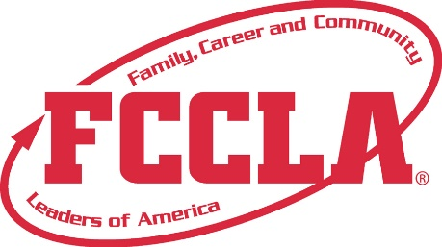

**FOR IMMEDIATE RELEASE**  **Contact:** *Your Name and Title*

**Phone:** *Your Phone*

**Email:** *Your Email*

**Franklin Covey Leadership Academy Recognition**

**Seattle, WA, July 2024 –** [Individual's Name] is delighted to have participated in the FranklinCovey FCCLA Leadership Academy this past spring. FranklinCovey FCCLA Leadership Academy empowers students with the leadership and life skills they need to thrive in the 21st Century. Allowing members to be recognized for their growth efforts, each academy has a unique focus and will help students develop leadership skills and self-confidence with peers in their grade level.

(Quote)

Using FranklinCovey resources, FCCLA Members got to experience in-depth training as part of the ultimate leadership experience.

In Spring 2025, FCCLA is offering the Life Readiness, Leadership Readiness, and College Readiness Courses. To learn more about these courses, please click [**here**](https://www.leaderinme.org/life-readiness/).

**About FCCLA®**

Family, Career and Community Leaders of America (FCCLA) is a dynamic and effective student-led nation-based organization supporting youth on their journey to become the leaders of tomorrow and helping them address important personal, family, work, and societal issues through Family and Consumer Sciences education. FCCLA has over 240,000 members and more than 5,200 chapters across the nation.

The Ultimate Leadership Experience is unique among youth organizations because its programs are planned and run by members. It is the only career and technical intracurricular student organization with a central focus on careers that support families. Participation in national FCCLA programs and chapter activities aids members in becoming strong leaders in their families, careers, and communities. For more information on FCCLA, please contact (Insert adviser Name) at (School Phone Number) or (Email Address).

###