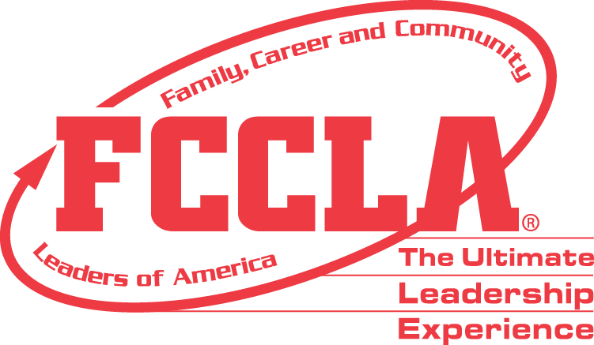

**FOR IMMEDIATE RELEASE** Contact: [NAME]

Phone: [CHAPTER NAME]

Email: [PHONE]

**[Student's Name] Awarded 2024 Hilton Hotels Hospitality Scholarship**

[City, State], [Date] — [Student's Name], a high school senior at [High School Name], has been awarded the prestigious 2024 Hilton Hotels Hospitality Scholarship by the Family, Career and Community Leaders of America (FCCLA). This $1,000 scholarship recognizes [Student's Name]'s outstanding dedication to the hospitality field and their commitment to furthering their education in this dynamic industry.

[Student's Name] was selected from a competitive pool of applicants based on their academic achievements, extracurricular involvement, and passion for hospitality. The selection committee, comprised of hospitality industry professionals and educators, commended [Student's Name] for their exemplary accomplishments and potential for success in the hospitality sector.

[He/She/They] will be attending [Name of College/University], a [two/four]-year degree-granting institution, starting in the Fall Semester of 2024, where [he/she/they] will pursue a degree in [specific field of hospitality if known, e.g., Hotel Management, Culinary Arts, Tourism].

The Hilton Hotels Hospitality Scholarship aims to support aspiring hospitality professionals by providing financial assistance for their education. Hilton Hotels is committed to nurturing future leaders who will shape the future of hospitality.

For more information about the Hilton Hotels Hospitality Scholarship and other FCCLA programs, please visit fcclainc.org.

**About FCCLA®**

Family, Career and Community Leaders of America (FCCLA) is a dynamic and effective student-led nation-based organization supporting youth on their journey to become the leaders of tomorrow and helping them address important personal, family, work, and societal issues through Family and Consumer Sciences education. FCCLA has over 240,000 members and more than 5,200 chapters across the nation.

The Ultimate Leadership Experience is unique among youth organizations because its programs are planned and run by members. It is the only career and technical intracurricular student organization with a central focus on careers that support families. Participation in national FCCLA programs and chapter activities aids members in becoming strong leaders in their families, careers, and communities. For more information on FCCLA, please contact (Insert adviser Name) at (School Phone Number) or (Email Address).

###