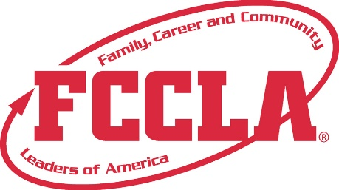

**FOR IMMEDIATE RELEASE**  **Contact:** *(Name, Title)*

**Phone:** *(Phone)*

**Email:** *(Email)*

***(Name or Number of Students)* from *(Name of School)* Competed in the National STAR Event Competition at the 2024 FCCLA National Leadership Conference in Seattle, WA, June 29 – July 3, 2024**

*(Include a photo with the press release)*

**Seattle, WA, July 2024** – The 2024 FCCLA National Leadership Conference (NLC) took place in Seattle, WA, from June 29 – July 3, drawing more than 8,000 students, educators, and guests from across the nation. This gathering provided a valuable platform for attendees to expand their leadership skills, sharpen their talents, explore career pathways, and listen to inspiring speakers.

The highly anticipated Students Taking Action with Recognition (STAR) Events were at the heart of the conference. Over 4,300 FCCLA Members competed in these events, where they were recognized for their proficiency and achievement in chapter and individual projects, leadership skills, and career preparation. The collaboration between youth and adults in managing the events and evaluating participants allowed students to develop real-world skills and gain valuable insights.

STAR Events are pivotal in supporting student development by enhancing their classroom experience and guiding them toward successful career pathways. With more than 30 events to choose from, participants had the opportunity to demonstrate their knowledge, skills, and abilities by actively addressing essential issues concerning families, careers, or communities. By researching the topic and implementing projects to advocate for positive change, students acquired valuable skills and industry insights needed to thrive in the 21st century.

We are thrilled to share that (Insert the Name(s) of Chapter Students) proudly represented (Name of School) at the FCCLA National Leadership Conference in Seattle, WA. They competed in the (Name of STAR Event They Competed in) STAR Event and achieved a remarkable (bronze/silver/gold) medal (insert here if student placed in top 10 or top 3) in recognition of their outstanding performance.

The students' project, (Insert more information here about the students’ project), exemplifies their dedication, creativity, and commitment to making a positive impact on the lives of others. Their accomplishment at the national level is a testament to their hard work, teamwork, and unwavering passion.

**About FCCLA**

Family, Career and Community Leaders of America (FCCLA) is a dynamic and effective student-led nation-based organization supporting youth on their journey to become the leaders of tomorrow and helping them address important personal, family, work, and societal issues through Family and Consumer Sciences education. FCCLA has over 240,000 members and more than 5,200 chapters across the nation.

The Ultimate Leadership Experience is unique among youth organizations because its programs are planned and run by members. It is the only career and technical intracurricular student organization with a central focus on careers that support families. Participation in national FCCLA programs and chapter activities aids members in becoming strong leaders in their families, careers, and communities. For more information on FCCLA, please contact (Insert adviser Name) at (School Phone Number) or (Email Address).

###