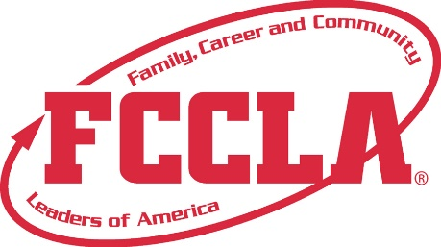

**FOR IMMEDIATE RELEASE**  **Contact:** *Your Name and Title*

**Phone:** *Your Phone*

**Email:** *Your Email*

**2024 National Leadership Conference Online Challenge Tests**

**Seattle, WA, July 2024 –** [Member’s Name], a dedicated member of [School Name/Chapter Name], is excited to announce their participation in the Online Challenge Tests at the 2024 National Leadership Conference (NLC). Developed in collaboration with Goodheart-Willcox Publisher, these 50-question tests were aligned with the National Standards for Family and Consumer Sciences (FCS) and provided members with the opportunity to demonstrate the skills they have acquired through their FCS courses and involvement in FCCLA.

The 2024 NLC featured ten Online Challenge Tests, covering a wide range of topics:

* Consumer Math Challenge (Levels 1-3)
* Culinary Math Challenge (Levels 2-3)
* Early Childhood Challenge (Levels 1-3)
* Education and Training Challenge (Levels 2-3)
* Fashion Construction and Design Challenge (Levels 2-3)
* FCCLA Knowledge Challenge (Levels 1-3)
* Hospitality, Tourism, and Recreation Challenge (Levels 2-3)
* Interior Design Challenge (Levels 2-3)
* Nutrition Challenge (Levels 1-3)
* Science in FCS Challenge (Levels 1-3)

[Member’s Name] chose to participate in the [Specific Challenge Test] at the [Specific Level], showcasing their expertise and commitment to excellence in the field of Family and Consumer Sciences.

"I am thrilled to have participated in the Online Challenge Tests and demonstrate the knowledge and skills I have gained through my FCCLA involvement," said [Member’s Name]. "This is a fantastic opportunity to compete at a national level and represent [School Name/Chapter Name]."

**About FCCLA®**

Family, Career and Community Leaders of America (FCCLA) is a dynamic and effective student-led nation-based organization supporting youth on their journey to become the leaders of tomorrow and helping them address important personal, family, work, and societal issues through Family and Consumer Sciences education. FCCLA has over 240,000 members and more than 5,200 chapters across the nation.

The Ultimate Leadership Experience is unique among youth organizations because its programs are planned and run by members. It is the only career and technical intracurricular student organization with a central focus on careers that support families. Participation in national FCCLA programs and chapter activities aids members in becoming strong leaders in their families, careers, and communities. For more information on FCCLA, please contact (Insert adviser Name) at (School Phone Number) or (Email Address).

###