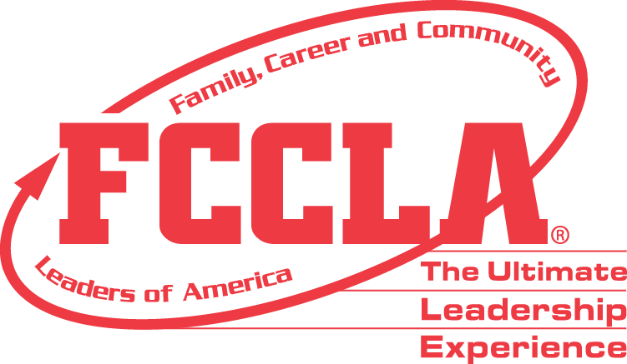

**FOR IMMEDIATE RELEASE** Contact: [NAME]

Phone: [CHAPTER NAME]

Email: [PHONE]

**[CHAPTER NAME] FCCLA Chapter Wins National [Program Name] Project Award**

RESTON, VA — [CHAPTER NAME], [STATE], was selected to receive the 2024 National [1st Place High School **OR** 1st Place Middle School **OR** Runner Up] FCCLA offers eight peer-to-peer educational programs to help students develop real-world skills for life within Family and Consumer Sciences (FCS) education. Each National Program is designed to be integrated into the FCS classroom to help reinforce lessons with opportunities for hands-on practice.

[Add program description]

As the national [1st Place High School **OR** 1st Place Middle School **OR** Runner Up], the [CHAPTER NAME] FCCLA Chapter will receive a [AWARD AMOUNT] award and was recognized at the 2024 FCCLA National Leadership Conference in Seattle, June 29 - July 3, 2024.

[INSERT PROJECT DESCRIPTION]

**About FCCLA®**

Family, Career and Community Leaders of America (FCCLA) is a dynamic and effective student-led nation-based organization supporting youth on their journey to become the leaders of tomorrow and helping them address important personal, family, work, and societal issues through Family and Consumer Sciences education. FCCLA has over 240,000 members and more than 5,200 chapters across the nation.

The Ultimate Leadership Experience is unique among youth organizations because its programs are planned and run by members. It is the only career and technical intracurricular student organization with a central focus on careers that support families. Participation in national FCCLA programs and chapter activities aids members in becoming strong leaders in their families, careers, and communities. For more information on FCCLA, please contact (Insert adviser Name) at (School Phone Number) or (Email Address).

###