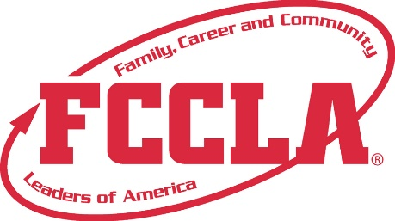

**FOR IMMEDIATE RELEASE**  **Contact:** *Your Name and Title*

**Phone:** *Your Phone*

**Email:** *Your Email*

**2025 National Leadership Conference Challenge Tests**

**Orlando, FL, July 2025 –** [Member’s Name], a dedicated member of [School Name/Chapter Name], is excited to announce their participation in the Challenge Tests at the 2025 National Leadership Conference (NLC). Developed in collaboration with Goodheart-Willcox Publisher, these 50-question tests are aligned with the National Standards for Family and Consumer Sciences (FCS) and provide members with the opportunity to demonstrate the skills they have acquired through their FCS courses and involvement in FCCLA.

The 2025 NLC featured ten Challenge Tests, covering a wide range of topics:

* Apparel: Fashion Design and Construction Challenge (Levels 1-4)
* Housing & Interior Design Challenge (Levels 1-4)
* Culinary Math Challenge (Levels 1-4)
* FCCLA Knowledge Challenge (Levels 1-4)
* Hospitality Services Challenge (Levels 1-4)
* Child Development: Early States Through Adolescence Challenge (Levels 1-4)
* Math for Financial Literacy Challenge (Levels 1-4)
* Nutrition & Wellness for Life Challenge (Levels 1-4)
* Principles of Food Science Challenge (Levels 1-4)
* Teaching Challenge (Levels 1-4)

[Member’s Name] has chosen to participate in the [Specific Challenge Test] at the [Specific Level], showcasing their expertise and commitment to excellence in the field of Family and Consumer Sciences.

"I am thrilled to have participated in the Challenge Tests and demonstrate the knowledge and skills I have gained through my FCCLA involvement," said [Member’s Name]. "This was a fantastic opportunity to compete at a national level and represent [School Name/Chapter Name]."

**About FCCLA®**

Family, Career and Community Leaders of America (FCCLA) is a dynamic and effective student-led nation-based organization supporting youth on their journey to become the leaders of tomorrow and helping them address important personal, family, work, and societal issues through Family and Consumer Sciences education. FCCLA has over 250,000 members and more than 5,200 chapters across the nation.

The Ultimate Leadership Experience is unique among youth organizations because its programs are planned and run by members. It is the only career and technical intracurricular student organization with a central focus on careers that support families. Participation in national FCCLA programs and chapter activities aids members in becoming strong leaders in their families, careers, and communities. For more information on FCCLA, please contact (Insert adviser Name) at (School Phone Number) or (Email Address).

###