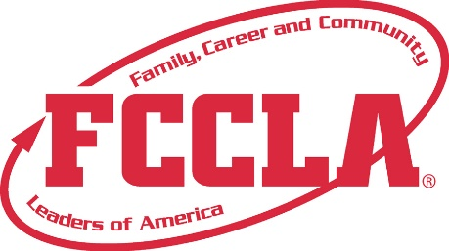

**FOR IMMEDIATE RELEASE**  **Contact:** *Your Name and Title*

**Phone:** *Your Phone*

**Email:** *Your Email*

**2025 National Leadership Conference Skill Demonstration Events**

**Orlando, FL, July 2025 –** [Member’s Name], a dedicated member of [School Name/Chapter Name], is excited to announce their participation in the Skill Demonstration Events at the 2025 National Leadership Conference (NLC). These events offered a platform for FCCLA members to showcase their college- and career-readiness skills in Family and Consumer Sciences (FCS) and related occupations.

Skill Demonstration Events provide an excellent opportunity for members to apply the knowledge and skills they have acquired through their FCS courses and FCCLA involvement. These events serve as an introduction to FCCLA's Competitive Events and require a shorter time commitment than STAR Events projects, making them accessible to a wide range of participants. National Standards for Family and Consumer Sciences (FCS) and provide members with the opportunity to demonstrate the skills they have acquired through their FCS courses and involvement in FCCLA.

This year, eight exciting Skill Demonstration Events were featured:

* Culinary Food Art (Levels 2,3)
* Culinary Knife Skills (Levels 1-3)
* FCCLA Creed Speaking & Interpretation (Levels 1,2)
* Impromptu Speaking (levels 1-3)
* Interior Design Sketch (Levels 2,3)
* Lesson Plan Development and Modifications (Levels 1-4)
* #TeachFCS (Levels 1-3)

[Member’s Name] participated in the [Specific Skill Demonstration Event] at the [Specific Level], showcasing their expertise and commitment to excellence in the field of Family and Consumer Sciences.

"I am thrilled to have participated in the Skills Demonstration Events and demonstrate the knowledge and skills I have gained through my FCCLA involvement," said [Member’s Name]. "This is a fantastic opportunity to compete at a national level and represent [School Name/Chapter Name]."

**About FCCLA®**

Family, Career and Community Leaders of America (FCCLA) is a dynamic and effective student-led nation-based organization supporting youth on their journey to become the leaders of tomorrow and helping them address important personal, family, work, and societal issues through Family and Consumer Sciences education. FCCLA has over 240,000 members and more than 5,200 chapters across the nation.

The Ultimate Leadership Experience is unique among youth organizations because its programs are planned and run by members. It is the only career and technical intracurricular student organization with a central focus on careers that support families. Participation in national FCCLA programs and chapter activities aids members in becoming strong leaders in their families, careers, and communities. For more information on FCCLA, please contact (Insert adviser Name) at (School Phone Number) or (Email Address).

###