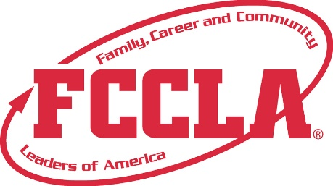

**FOR IMMEDIATE RELEASE**  **Contact:** *(Name, Title)*

**Phone:** *(Phone)*

**Email:** *(Email)*

**Student Represents [School Name/Chapter Name] at FCCLA National Leadership Conference**

**City, State –** [Student Name], a member of the Family, Career and Community Leaders of America (FCCLA) Chapter at [School Name], recently competed at the FCCLA National Leadership Conference (NLC) held in Orlando, FL from July 5-July 9, 2025. The conference welcomed thousands of students from across the nation for a week of competition, leadership development, and career exploration.

[Student Picture]

The National Leadership Conference brought together thousands of student leaders from across the country to compete in **Students Taking Action with Recognition (STAR) Events**, attend leadership workshops, and network with other FCCLA members. [Student Name] represented [State] in the [Name of STAR Event] event and [insert outcome if applicable, e.g., earned a silver medal / placed in the top 10 nationally / was recognized for outstanding achievement].

“Presenting my project, [Project Title], which focused on [brief project description], at the National Leadership Conference was an amazing opportunity. I’m proud of what I accomplished and inspired by the other students I met,” said [Student Name].

The National Leadership Conference provided [Student Name] with a dynamic experience that strengthened leadership skills, built career readiness, and encouraged meaningful connections with peers nationwide. Through competitive events, workshops, and networking opportunities, [he/she/they] gained valuable insight into future career paths and the power of youth-led impact. [Student Name] looks forward to applying these experiences to future leadership roles, continued involvement in FCCLA, and creating positive change in [his/her/their] school and community.

**About FCCLA**

Family, Career and Community Leaders of America (FCCLA) is a dynamic and effective student-led nation-based organization supporting youth on their journey to become the leaders of tomorrow and helping them address important personal, family, work, and societal issues through Family and Consumer Sciences education. FCCLA has over 240,000 members and more than 5,200 chapters across the nation.

FCCLA: The Ultimate Leadership Experience is unique among youth organizations because its programs are planned and run by members. It is the only career and technical intracurricular student organization with a central focus on careers that support families. Participation in national FCCLA programs and chapter activities aids members in becoming strong leaders in their families, careers, and communities.

###