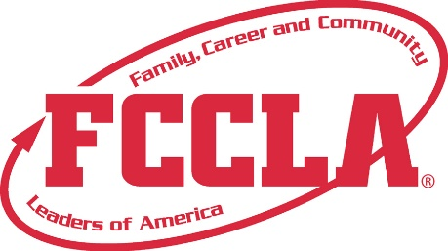

**FOR IMMEDIATE RELEASE**  **Contact:** *(Name, Title)*

**Phone:** *(Phone)*

**Email:** *(Email)*

**Student to Represent [School Name/Chapter Name] at FCCLA National Leadership Conference**

**[City, State] —** [Student Name], a student at [School Name] and member of the Family, Career and Community Leaders of America (FCCLA) will represent [School/State] at the upcoming FCCLA National Leadership Conference (NLC), to be held in Orlando, FL from July 5–9, 2025. The conference will bring together thousands of students from across the country for a week of competition, leadership development, and career exploration.

FCCLA’s Students Taking Action with Recognition (STAR) Events challenge youth to apply classroom learning to real-world situations through projects focused on community service, career preparation, advocacy, and personal development. [Student Name] earned the opportunity to advance to nationals after a strong performance at the state level with their project, [Project Title], which focuses on [brief description of project].

“After competing at the state level, I’m proud to have qualified for nationals and to represent [School/State] at the National Leadership Conference,” said [Student Name]. “I’ve put a lot of time and effort into my project, and I’m excited for the opportunity to share it and learn from other student leaders from across the country.”

The National Leadership Conference also offers workshops, college and career exhibits, and networking opportunities with FCCLA Members from across the U.S. [Student Name] looks forward to gaining new leadership skills, exploring future career paths, and bringing back fresh ideas to their chapter and community.

FCCLA is a national Career and Technical Student Organization that helps young people become leaders by addressing important personal, family, work, and societal issues through Family and Consumer Sciences education. Participation in FCCLA builds leadership, communication, and career-readiness skills that benefit students for a lifetime.

For more information about FCCLA and how to get involved, visit [insert school or state FCCLA chapter website].

**About FCCLA**

Family, Career and Community Leaders of America (FCCLA) is a dynamic and effective student-led nation-based organization supporting youth on their journey to become the leaders of tomorrow and helping them address important personal, family, work, and societal issues through Family and Consumer Sciences education. FCCLA has over 240,000 members and more than 5,200 chapters across the nation.

FCCLA: The Ultimate Leadership Experience is unique among youth organizations because its programs are planned and run by members. It is the only career and technical intracurricular student organization with a central focus on careers that support families. Participation in national FCCLA programs and chapter activities aids members in becoming strong leaders in their families, careers, and communities.

###