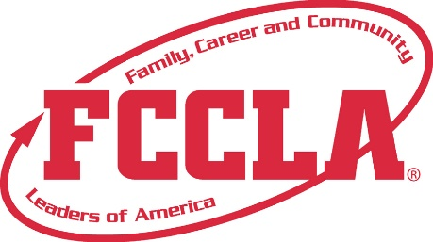

**FOR IMMEDIATE RELEASE**  **Contact:** *(Name, Title)*

**Phone:** *(Phone)*

**Email:** *(Email)*

**[Student Name] Earns National Recognition in FCCLA Top 10 Finish**

[City, State] — [Student Name], a member of [School Name]’s Family, Career and Community Leaders of America (FCCLA) chapter, has placed in the Top 10 nationally for their event at the FCCLA National Leadership Conference (NLC), held July 5–9, 2025, in Orlando, Florida.

Competing in the Students Taking Action with Recognition (STAR) Events, [Student Name] advanced through the state level to showcase their project, *[Project Title]*—a project focused on [brief description of project, e.g., financial literacy education for teens]. Their outstanding performance placed them among the top competitors in the nation.

“I’m beyond honored to be recognized in the Top 10 at nationals,” said [Student Name]. “This experience has pushed me to grow not just as a student, but as a leader. It’s incredible to see all our hard work celebrated on a national stage.”

FCCLA’s STAR Events encourage students to apply classroom learning to real-world challenges through competitive presentations in areas such as advocacy, entrepreneurship, public speaking, and more. Top 10 recognition is a prestigious honor that reflects exceptional dedication and skill.

In addition to competing, [Student Name] participated in leadership workshops, networking sessions, and college and career exhibits alongside thousands of peers from across the country. They return home with new ideas, connections, and motivation to continue making an impact in their school and community.

For more information about FCCLA and how to get involved, visit [insert school or state FCCLA chapter website].

**About FCCLA**

Family, Career and Community Leaders of America (FCCLA) is a dynamic and effective student-led nation-based organization supporting youth on their journey to become the leaders of tomorrow and helping them address important personal, family, work, and societal issues through Family and Consumer Sciences education. FCCLA has over 240,000 members and more than 5,200 chapters across the nation.

FCCLA: The Ultimate Leadership Experience is unique among youth organizations because its programs are planned and run by members. It is the only career and technical intracurricular student organization with a central focus on careers that support families. Participation in national FCCLA programs and chapter activities aids members in becoming strong leaders in their families, careers, and communities.

###