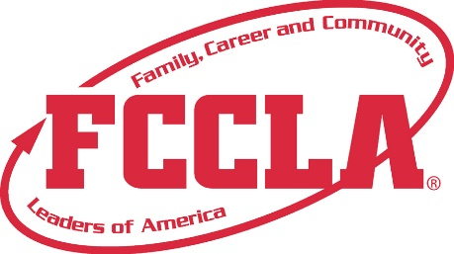

FOR IMMEDIATE RELEASE Contact: (Name, Title)
Phone: (Phone)
Email: (Email)

[CHAPTER NAME] FCCLA MEMBERS PLACE AMONG TOP 10 IN THE NATION

[CITY, STATE], [DATE] – [Student Name(s)] of the [Chapter Name] Chapter of Family, Career and Community Leaders of America (FCCLA) earned national recognition by placing among the top 10 in the nation at the 2026 FCCLA National Leadership Conference, held July 6–10 in Washington, D.C.

[Student Name(s)] competed in [STAR Event Name and Level] and earned [National Placement or Top 10 National Finalist recognition]. The event challenged participants to [briefly explain what the event required or what the project focused on].

STAR Events, which stands for Students Taking Action with Recognition, allow FCCLA Members to apply the knowledge and skills they develop through Family and Consumer Sciences education to real-world projects, presentations, and career-related challenges. Participants advance through local and state competition before earning the opportunity to compete at the national level.

“[Insert a quote from the student about the achievement, preparation, or what the experience meant],” said [Student Name], [Grade Level and/or FCCLA Position].

[Add one short paragraph about the project, preparation, community partners, other chapter competitors, or additional results.]
“[Insert a quote from the chapter adviser about the student’s dedication, growth, or national achievement],” said [Adviser Name], FCCLA Adviser at [School Name].

The [Chapter Name] FCCLA Chapter was among [Number] delegates from [State] and more than 10,000 FCCLA Members, Advisers, and guests from across the nation, Puerto Rico, and American Samoa who attended the conference.

The FCCLA National Leadership Conference brings students and educators together for Competitive Events, leadership development, career exploration, educational workshops, and national recognition. The 2026 conference was especially historic because it was held in Washington, D.C., during the America 250 celebrations.

“Hosting the 2026 National Leadership Conference in Washington, D.C., during the America 250 celebrations created a powerful and historic opportunity for FCCLA Members,” said Sandy Spavone, CEO of FCCLA. “These students are building the skills, confidence, and connections to make an impact in their schools, careers, families, communities, and country right now.”

For more information or to learn how you can support the [Chapter Name] FCCLA Chapter, please contact [Adviser Name] at [Email Address and/or Phone Number].

About FCCLA
Family, Career and Community Leaders of America (FCCLA) is a national Career and Technical Student Organization that prepares students for careers that support the family through Family and Consumer Sciences education. Since 1945, FCCLA has provided leadership development, workplace readiness, and career preparation opportunities that equip students with the skills needed for success in life and work. Guided by dedicated Family and Consumer Sciences educators, FCCLA Members develop critical thinking, communication, collaboration, leadership, and problem-solving skills while exploring career opportunities aligned with the national Career Clusters. With more than a quarter of a million FCCLA Members in over 5,500 chapters nationwide, FCCLA continues to prepare the next generation of leaders to make a lasting impact in their careers, families, and communities.

###

