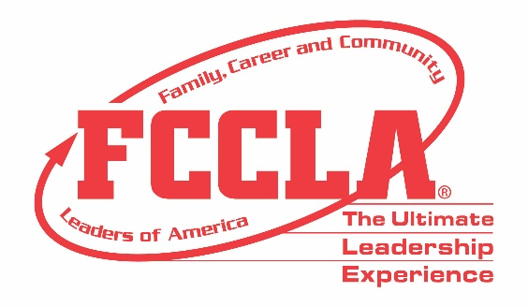

FOR IMMEDIATE RELEASE Contact: Marissa Kunerth
Communications & Public Relations Manager
Phone: 703.716.1308
Email: mkunerth@fcclainc.org

(Insert Teacher Name), Family and Consumer Sciences Teacher from (Insert School/Chapter Name) is Named Adviser Mentor Award Recipient at National Leadership Conference

Reston, VA – (Insert Teacher Name) is one of 13 honorees across the nation selected by Family, Career and Community Leader of America (FCCLA) to receive the 2020-2021 Adviser Mentor Award. FCCLA will honor all Adviser Mentor Award recipients during the Hybrid National Leadership Conference, June 27-July 2, 2021, in Nashville, TN.

The FCCLA Adviser Mentor program acknowledges exceptional, experienced Family and Consumer Science (FCS) educators who excel in FCS and FCCLA. These skilled FCS teachers train, assist, and familiarize new FCCLA advisers as they adjust to their new role and responsibilities within FCCLA.

All FCCLA advisers have the opportunity to be recognized as an Adviser Mentor. To achieve this award, advisers must first earn Master Adviser Recognition. Such recognition can be accomplished by devoting two years to new adviser assistance, assuming adult leadership roles in FCCLA, conducting adviser workshops, attending training workshops, and utilizing national and state FCCLA resources.

(Insert paragraph about Adviser’s FCCLA chapter and FCS professional accomplishments)

“Adviser Mentors are crucial to our continued growth at FCCLA,” said Sandy Spavone, Executive Director of FCCLA. “Their knowledge, experience, and devotion to the organization is shared with incoming advisers, who carry out their learned skills throughout the entire program. Our mentors are an instrumental reason we can continue to flourish and evolve.”

FCCLA student success is predominantly due to the guidance, support, and leadership of chapter and state advisers. To serve as an adviser requires an enormous amount of time, energy, and commitment. Exceptional advisers continuously go above and beyond by staying well informed, connecting students to opportunities and resources, and making significant contributions to FCCLA on the local, state, and national level.

About FCCLA
Family, Career and Community Leaders of America (FCCLA) is a dynamic and effective national student organization that helps young men and women become leaders and address important personal, family, work, and societal issues through Family and Consumer Sciences education. FCCLA reaches more than 180,000 members and over 5,000 Family and Consumer Sciences educators in the United States and territories.
###

