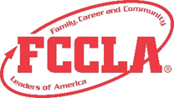
EVENT VOLUNTEERING EXPERIENCE SUMMARY FORM
Required for Level 2 and 3. Complete this form and include it in your portfolio, along with 1-2 photos of the event documenting your participation. Volunteer at a community event in which at least 50 people attend, and which requires a minimum of 2 hours of volunteering service per team member. The event does not need to be related to the planned project.
Event Name
Event Location
Event Organizer/Manager
What is the event goal?

What is/are the event objective(s)?

How is the success of the event measured?

How many volunteers are involved, and what are their roles?

How was the event promoted or advertised?

What kinds of choices and decisions did the event organizers make?

What were the challenges associated with this event? How were they handled by the event organizer/manager?

What recommendations would you have to improve this event?

